Nunavut: Our Land

A Two-Way Learning Unit for Inuit Students

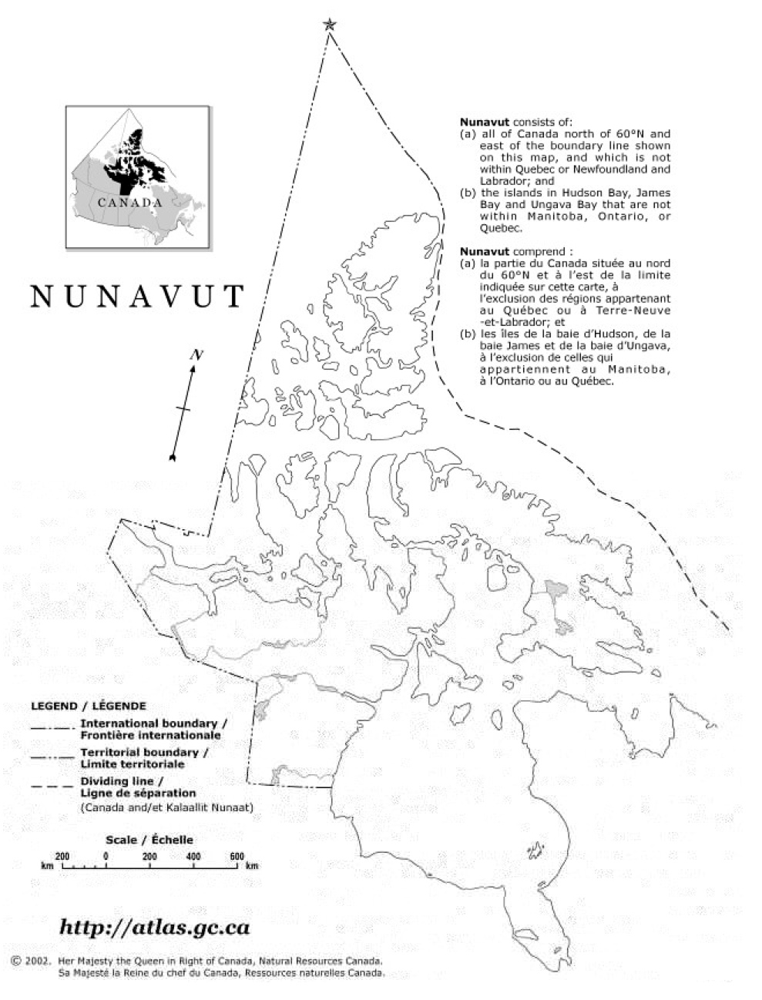
Canadian Council for Learning
University of Manitoba Centre for Research, Youth, Science Teaching and Learning
August 2009
Table of Contents

Topic Page
Acknowledgements 3
Guiding Principles of the Unit 4
Cross-Curricular Applications 6
Skills Development 7
Attitudes and Beliefs Development 8
Curriculum Applications 9
Things to Consider in Preparing to Teach the Unit 10
About the Activities 11
Activities 13
Elder’s Interviews 86
References 121

Acknowledgements

The development of this resource for northern teachers and students especially in the northern Qikiqtani region has been made possible through the granting agency Canadian Council for Learning and the Natural Sciences and Engineering Research Council. Their support has ensured that Inuit students are provided with the opportunity to learn about their culture, especially when they study science, in Inuktitut.

The development of this resource has also been made possible through the support of many elders from the communities of Pond Inlet, Igloolik and Clyde River. Many elders and community members have given their time and knowledge to ensure that their experiences can be recorded and incorporated into learning activities valuable for their community’s children.

As well, the school communities of Quluaq School in Clyde River, Ullajuk School in Pond Inlet and Atuguttaaluk School in Igloolik are thanked for their support in the development of the learning activities outlined in this booklet.
Contact details:

Dr. Brian Lewthwaite
Dr. Barbara McMillan
Faculty of Education
University of Manitoba

Guiding Principles of the Unit

- Provide two-way learning experiences by integrating Inuit knowledge, ways of knowing, beliefs and values and contemporary scientific knowledge, processes and attitudes.
- Draw upon traditional and contemporary Inuit cultural examples as contexts for student learning.
- Include the local community and its people in students’ learning opportunities as the classroom is an extension of the school and local community.
- Foster language development in Inuktitut and, where required or encouraged, English.
- Use diagnostic and formative assessment to inform planning and teaching and monitor student learning.
- Engage students by starting lessons by providing first-hand experiences for students or drawing upon students’ common experiences.
- When using story to engage students, use the interrupted-story-line as a vehicle to prompt first-hand investigations.
- Deliverately promote scientific attitudes of mind (curiosity, problem-solving, working to end) through thoughtful independent consideration of questions and challenges posed.
- Move from the experiential, first-hand experiences to the psychological; that is, after providing concrete experiences assist students in making sense of the experiences by using purposeful strategies to promote understanding such as role plays, illustrations and analogies.
- Assist students in their consolidation of ideas only as an extension of the initial experiential and psychological learning experiences.
- Within the lesson and throughout the unit, move from concrete to more abstract ideas.
- Provide opportunities for student-initiated and direct investigations.
- Provide opportunity for students to make connections among science and all other learning areas.
- Foster student independence, creativity and curiosity by providing opportunity for students’ ideas and questions and follow-up opportunities for problem solving and investigation
- Provide students with the opportunity to make connections between what they are learning and carreer opportunities.

Cross-Curricular Applications

This unit is developed with an emphasis on developing oral and written language skills within the context of landforms and geography. The activities that are recommended encourage student expression of their experience in written, visual and oral form.

This unit has strong connections to appreciating the importance and diversity of the geography and landforms within Nunavut, both within a historical and contemporary context. Particular emphasis is placed on the understanding of sense of place. Students are encouraged to look at sense of place from the perspective of local, national and international. Although a Social Studies Unit, ‘Our Land’ is meant to be looked at holistically, with the understanding that there are many factors and teachable subjects that relate to this unit. A special emphasis is placed on areas of significance; that is, places important to people especially because of events that have occurred there or resources these places provide. By so doing, it is hoped that students will gain a better understanding of their past and a greater respect for their land in the future.

Students are encouraged to explore a variety of landforms throughout their local area, territory and internationally. They are encouraged to do this with the assistance of persons within the community who have experience and expertise in the suggested activities, both in traditional and contemporary knowledge.

The activities suggested are starting points and can fit in with several areas of other subjects to expand learning. Broaden the focus by adding stories and activities from the experiential base of your community.

Skills Development

This Unit emphasizes that the learning of science ideas is inextricably linked to the development of the processes of science. As asserted by the Northwest Territories Elementary Science Primary Program Guide, the legislated curriculum for Nunavut schools in 2008, science experiences should provide opportunity for the development of conceptual understanding within the context of relevant investigative experiences. Although individual scientific process skills may be emphasized in specific activities, they are to be supported more holistically in teacher-facilitated or student-directed inquiry.

The skills to be developed are expected to be appropriate to the level of the learner. These skills and a typical developmental sequence are outlined in detail in the NWT Primary Program Guide. Attention is given to providing students with first-hand experiences that promote skills such as:

Observing Communicating
Classifying Measuring
Predicting Planning Investigations
Inferring Interpreting Information
Recording Formulating Investigative Questions

These skills involve coordination between cognitive and muscular skills, often referred to as psychomotor skills. Handling and manipulating equipment require not just the physical ability to perform a task but also the intellect to know how to measure or observe accurately. It is anticipated that by the end of upper elementary a student might be able to, with assistance, conduct a scientific investigation. This unit provides opportunities for students to work physically and cognitively towards this end.

Attitudes and Beliefs Development

An explicit goal in the development of this resource and the other resources being developed in this Qikiqtani project and the accompanying professional development provided for teachers is to use these as a vehicle to contribute to student ‘success’ in science. Although success in science is often attributed to measurable outcomes such as knowledge acquisition and development, the intent of this development project is much more encompassing. It extends this notion of success to investigate the influence of ‘two-way’ learning experiences on students’ perceptions of success in their personal attitudes and beliefs.

What does success in science mean to Inuit students? It is anticipated that students will experience success in a variety of ways, beyond the border of knowledge into the domain of attitudes and beliefs. Attitudes are regarded as states of mind, behavior or conduct regarding some matter, as indicating opinion or purpose. The program of study suggested in the activities that follow will foster student curiosity and creativity, and openness to new ideas and ways of thinking. As well students will develop confidence in their perceptions of self as students of science. Similarly they will develop confidence as evidence in risk-taking and their effort to conduct science investigations. Their participation in the processes of science will foster their perseverance, precision and objectivity in solving scientific problems. As members of a team they will develop in their respect for and ability to work cooperatively towards purposeful goals with their peers.

Above all, It is anticipated that students will develop a more positive sense of themselves as Inuit in contemporary society as they learn about the inextricable link between science and the world in which they live. It is anticipated that students will see science as a part of their life trajectory both in future formal and informal settings as a result of study that advocates ‘two-way’ learning.

Curriculum Applications

In this context, the conceptual knowledge base and essential skills identified by these curricula are paired with Inuit cultural values, beliefs, and heritage to become the cornerstone of the learning provided in this unit. The concept of ‘Our Land’ and Sense of place are commonly addressed in Pan-Canadian Social Studies curriculum. The four general learning outcomes that provide part of the conceptual structure for social studies from Kindergarten through Senior high, which relate to this unit include (as stated in the Manitoba Social Studies curriculum: A Foundation For Implementation) are:

Identity, Culture, and Community
- Students will explore concepts of identity, culture and community in relation to individuals, societies, and nations

The Land: Places and People
- Students will explore the dynamic relationships of people with the land, places, and environments.

Historical Connections
- Students will explore how people, events, and ideas of the past shape the present and influence the future.

Global Interdependence
- Students will explore the global interdependence of people, communities, societies, nations, and environments.

Things to consider in preparing to teach the unit

In order for you to foster the development of the conceptual knowledge base and essential skills paired with Inuit cultural values, beliefs, and heritage in this unit, give consideration to the following:

Your students’ capabilities and interests:

- What will be the language of instruction? If the language of instruction is English, how can you include and affirm Inuktitut in your instruction?
- Will students be keeping a written learning log? Again, will it include and affirm Inuktitut?
- What contexts suggested are likely to be of most interest and relevance to your students?
- Should the investigations suggested be teacher or student-directed?
Your capabilities and interests:

- Consider the conceptual knowledge base, essential skills and Inuit cultural values, beliefs, and heritage affirmed by this unit. Where will you find the teaching challenging?
- What personal experiences, knowledge and skills can you bring to this unit? The unit provides opportunity for your strengths to be incorporated into the unit.

The capabilities and interests of your teaching context:

This resource has been developed with consideration for northern regions and its students. How can you work collaboratively with the school community to see the intentions of the unit a reality? Who are the individuals that can assist in ensuring Inuit Qaujimajatuqangit is incorporated into this unit?

About the Activities

Select a starting point:

Although a sequence of instruction has been provided for this unit of study, your starting point will be a reflection of your students’ backgrounds and interests. Upper elementary teachers are encouraged to start with the lower elementary activities.

Select knowledge, beliefs & values to develop:

Again, consider the interests of your students especially in terms of their Inuit Qaujimajatuqangit background.

Select appropriate skills to develop:

Consider the investigative abilities of your students. What investigative skills are most appropriate for your students? The investigations suggested could either be teacher-facilitated or student-directed depending on the capabilities of your students. What is most appropriate?

Develop an instructional sequence:

Use the information provided in previous sections of this resource to assist in developing a coherent instructional sequence. The list of activities is only a suggestion of what might be addressed. Focus on the General Learning Outcomes.

Do This Unit at the Start of the Year:

This unit was developed as a model using specific information relating to Igloolik, Nunavut. It was developed as a holistic approach for students to learn and investigate ‘Our Land’. Teachers are recommended to adapt this unit and use it as a model for teaching in their community, especially at the start of the school year when going outside is something students will want to do and the weather suits. The information within is easily transferrable to other communities.

Students Already Have Knowledge of Their Home Community and Its History

What you need:

Disposable or preferably digital cameras for each student
Computer to download the pictures onto
Projector
Otherwise, paper for students to draw pictures on
A map of the local area including a detailed map of the community

What you do:

- As a new teacher in the north and with very little knowledge of the students and sense of place in the north, I would like to have the students show me ‘their land’. It would be dependent upon the resources available.
- Begin by introducing the project to the students.
- Explain that I want to know how they see Igloolik - through their eyes, where they live.

What is important to them in Igloolik AND around the island?
What places are important to the community and people?
What are the names of the places” What do the Inuktitut names mean in English?
What places have stories and history?

Be sure to state that these places do not have to be man-made; that is, they can be natural features. Anything that they think is important.
- There are many ways to approach this. Ideally, you might take the students for walk (or preferably, they will take you) around the community having a Teaching Assistant or someone familiar to the students and the community, come with you; someone who can speak Inuktitut and English. Or, you may get students to use family or their own digital cameras or drawing paper and tell them that they will have to take pictures, collect pictures or draw pictures either from the walk or from their knowledge of the community.
- Ask them to give some indication of their awareness of geographical features and buildings, both new and, especially, old, about their community. You must try to create a sense of wonder and inquiry about some historical buildings or locations near or in the community.
- Ask them questions for consideration. Help students to see their community through new eyes through these questions. That is, what they have seen many times before maybe something they have taken for granted and never given consideration to.
- Ensure that students take/draw/collect pictures not only within the town, but also, from their experience, around the island. Encourage students to use a familiar format in their presentation work; that is, name of place, its significance; its name; its location.
- Give students notice of when the cameras/drawings/pictures are to be handed in or electronically submitted to you. When this is done, organize the pictures into a slideshow or a book about their town, or more importantly, a wall collage and present all of the pictures/drawings to the students. Get each student responsible for the page to present their information to the class allowing other students to contribute to their stories.
- Despite being a great exercise to activate students’ sense of place, this will give myself a great idea of students’ sense of place, and what is important to them. Some of the pictures could also possibly be used for later lessons. It is important that if students bring pictures from home, they are identifiable as belonging to students’ families.
- While doing the slideshow/collage, ask students questions about the pictures.

Where it is located? Why they picked it? What is the importance? The most important part is to have the students tell me about the pictures.
- Have the students try to pick out themes. What groups do most of the pictures fit into? If pictures were printed off, a fun activity would be to try to group the pictures on a wall. These pictures could be left on the wall as a resource for the upcoming lessons.

What you look for:
- Do students recognize important landforms/places around Igloolik?
- Can students tell you why a place is important?
- Have students’ sense of place been activated?
- Do they have a sense of wonder about aspects of their community?

We live in Igloolik

What you need:

Data on Igloolik now
A large map of Igloolik townsite and Island (possibly and OHT or map drawn on paper from an OHT)
Paper for each student to draw his or her maps on

What you do:

- To begin the class, show students a large council map of the community but with little detail of the island or area outside of Igloolik.
- Allow students time to tell you about Igloolik in their words. This lesson would tie in well with the pictures from the previous lesson. Have students talk about the town and locations near Igloolik on the island and areas that are of importance to them and the community.
- Find out from students where they live, what is in the town, how many people are there, and what people do. The purpose of this is to try to engage in a class discussion and expand on the dialogue between teacher and students. Record information collected on the board.
- It is important to activate the students’ knowledge, to do this, find out what students can tell you about the land, the town, its occupants and the surrounding area off-shore of the island. Expand on conversations as much as possible.
- Allow follow up from each response and allow for group interaction with each response. Most of the talking should be student driven (yet teacher directed).
- Find out from students what else is on the island? What makes up the island? Why is it important? Also, find out if students’ families still have summer camps, or what are the traditional areas possibly used by their grandparents?
- When students seem to have exhausted telling you about Igloolik (or just get tired of that activity), move on to an activity that doesn’t involve so much talking. Have students draw their own map of Igloolik individually, the town and the island. This is to activate the students thinking about what Igloolik looks like in their head and will help the teacher have a clearer picture of what the students already know.
- Allow students the opportunity to share their mapping ideas and to begin to work towards a common map of the community.
- Near the end the class, as a group activity have students place the areas discussed in class on a larger map. The template that follows could be finally used to make an overhead to create a large map to be placed on the classroom wall. How do their conceptions of their island compare to this map? Again, this will be the start of a large collection of information that will go on the walls.
- Have students use this larger map to more precisely identify areas of significance, either historically or in current times.
- Place names of places on the map including areas where events have occurred or resources are located.

What you look for:

- Can students draw a map of Igloolik?
- Can students place Igloolik on the island?
- Can students demonstrate prior knowledge?
- Did students engage in discussion about the town and island?
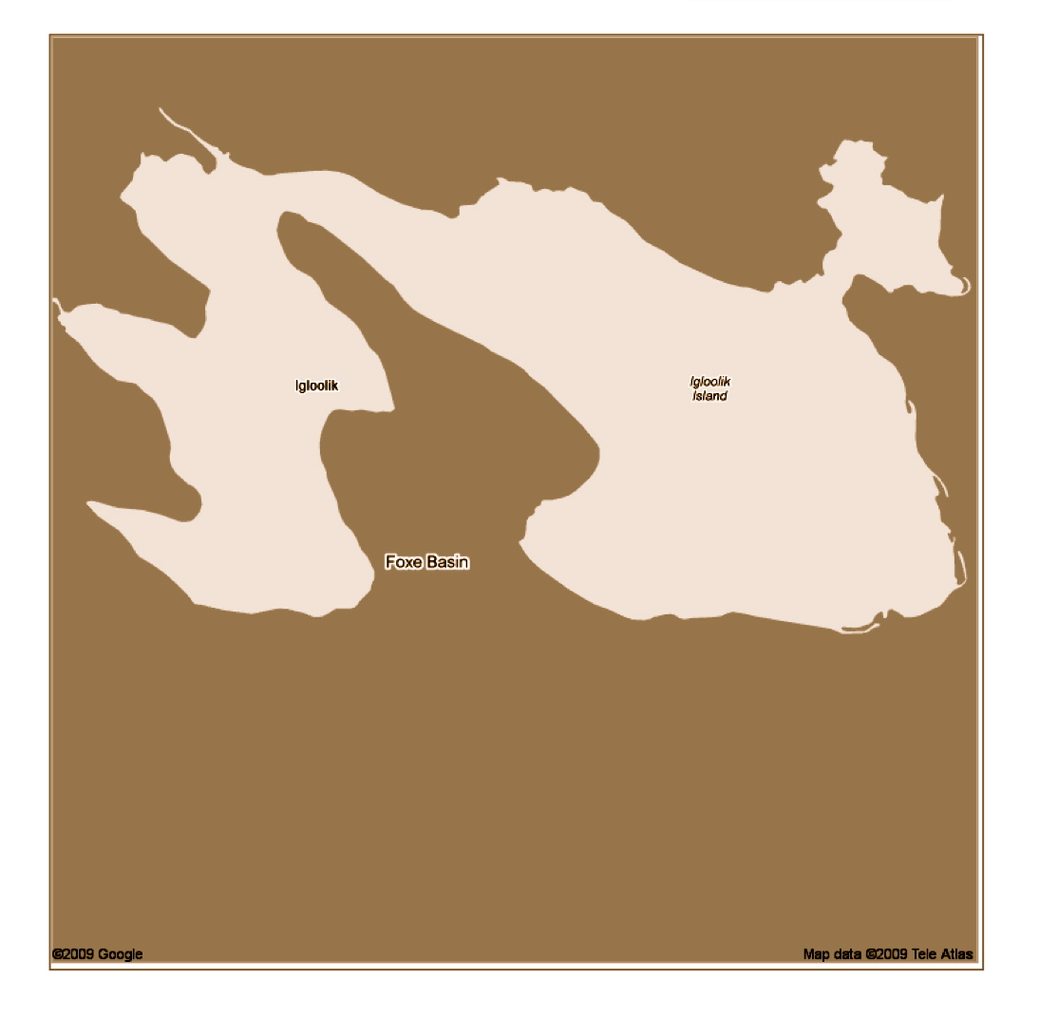
Source: Google Maps

What is the History of Igloolik?

What you need:

Elder to come into the class and discuss the history of Igloolik
Historical (archaeological) data of Igloolik

What you do:
- Ask students to share their knowledge of the history of Igloolik. Find out what they already know. Ask students if the town has always been there, if Inuit people have always lived on the island, what does Igloolik mean? The idea is to move into a higher level thinking than what was talked about in the previous classes.
- It would be best to have an elder or someone familiar with the traditional knowledge of Igloolik to come in and talk to the class about the history. Have the elder focus on how long the Inuit have been on Igloolik, why they chose the site for the town, has the settlement always been in the same spot, and what does Igloolik mean? It may also be useful to find out from the speaker how traditional knowledge compares to that of the archaeological information. Allow the students to ask the speaker questions.
- If a speaker is not available, read an Elder story or two about the history of Igloolik or get the students to as a family member about a place of significance. Allow students to ask questions and find out who else we could find the answer from? Who in the community might know the answer if the teacher does not. The students could try to find out this information from their families or others in the community. This could be worked into the lesson as an assignment.
- Activity – What do we learn from the Elder’s stories. Have students draw a picture of one of the stories and include what they have learned from the story and what they would like to know more about.
- You may wish for the students to take an island map home to collect stories from family members.

What you look for:
- Can students recall the stories?
- Can students outline things they’ve learned from the stories?
- Do students understand the history of Igloolik?
What did we learn from the Elder stories?

Draw a picture of one of the stories

What did you learn from the Stories?
What do you want to know more about?

There is a History to Other Places of Significance in Our Area

What you need:

Map of Igloolik Island
Elder stories of areas of significance or Elder to come talk to the class

What you do:

- On a big map of Igloolik Island have students identify the areas of the island that they know of. It may be helpful to make a large map of the island that hangs in the classroom for easy access throughout the unit. The map that was made in Lesson 2 would be appropriate be used again for this lesson. Students should feel like they ‘own’ the maps on the wall, and feel comfortable continually adding to the maps.
- If there are areas that the students have not talked about, ask them about the area. What about this area? What is it called? Have any of you been there? Is there anything important about this area? What is in this area: rocks? ice? water? Resources? Events?
- As with the previous lesson, having an elder or someone with traditional knowledge would be preferred. If not, locate stories from family members about different areas of significance around Igloolik. Should the lesson focus on reading stories, not the Elder’s stories, be sure they talk about how the areas got their name and why they are important.
- Once the speaker has finished, if appropriate, invite the students to share any stories they may have of these areas as well.
- Activity – Have students fill out the KWL worksheet, what did students already know, what do they want to know more about, and what did they learn from the stories? They can write or draw pictures. Have the students choose just one area to focus on for the worksheet. This class may need to be split into two, depending on how in depth the stories are and how much more the students want to know about the stories.
- This might be a good place to introduce the concept of naming to the class. Not only would it help for transition into future lessons, but having the elder in the classroom is a good opportunity to tap into authentic knowledge.
- Get students to consider the source of the names of areas. Are the names of places on the island named after people? Descriptive landforms? Resources? Events?
- Help students to recognize the source of various names.
- Do they have questions about areas that they seek answers too?

What you look for:

- Can students identify places on the map?
- Can students relate stories to place?
- Were students able to finish the KWL worksheet and engage in questioning with the speaker?
- Are there questions arising that you can see are sources of inquiry?

What did you learn from the Elder stories?

What did you already know about _______________ ?
What did you learn?
What do you still want to know?

There are Inuit and English Terms for Geographical Features

What you need:

List of geographical features around Igloolik and Nunavut
Inuit/English terms and definitions
Maps of Igloolik Island for each student, including outline map and a physical features map.
Maps of the greater area around Igloolik
Access to the Internet if a physical map is not available.
Help from someone to help with Inuktitut.

What you do:

- Begin by showing a large illustration of the local area; possibly an image from Google Earth or from a topographical map. This might be done on an OHT and projected on a whiteboard so that names can be placed beside each.
- Spend some time outlining what a geographical feature is - an observable feature that has special characteristics such as a lake, stream, hill, mountain, river, point, bay, river, beach, peninsula, isthmus. Identify these on a map collectively, and describe and explain them.
- All of these have Inuit and English names. Get the students to provide the Inuit terms for all of the geographical features as they are located on the map. Beside each write down words in both languages. Again, use students or your TA to assist this language development.
- Provide students with the following handout that allows them to compare the Inuktitut word and English word for the geographical feature. Allow students time to fill out the worksheet as the class goes along.
- Ask students to tell you about the features. Chances are they know the English and Inuktitut word for these features already. As the features are being discussed, allow time to talk about them in more depth. I.e.

Ask why are they there, how did they form, are they important, why?
- When this activity has wrapped up, another map activity could be to use different areas accessible through Google Maps. Using either map or one of your choice, allow the students to locate some of the landforms on the maps. These maps should be blown up and added to the previous wall map. Possibly major cities could be used as examples.
- Have students add some of the landforms or place names to the map.
- Once located, find out if the students know the names of the landforms or areas, and go over these. This activity will help the students start to expand their knowledge from local to territorial. It is also likely that some of the students may have intimate knowledge of some of the areas surrounding Igloolik and could share with the teacher and class.
- An important characteristic to outline throughout this lesson is for students to look for patterns of names. Specifically, the majority of names are not usually after people, but for resources, events and/or landmarks.

What you look for:
- Can students relate the Inuit terms with the English terms?
- Do students know the Inuktitut terms for these features?
- Are students familiar with the geographical features?
- Can they recall the meaning or description of the geographical features?

There are Inuit and English Terms for Geographical Features
Inuktitut English Description & Drawing

Map: Igloolik & Area

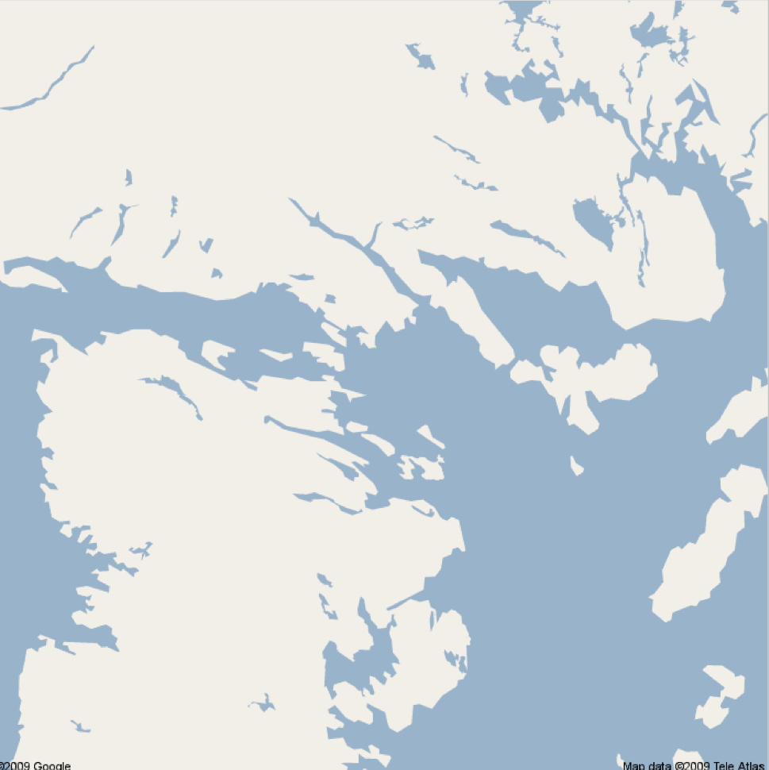

Map: Northern Canada

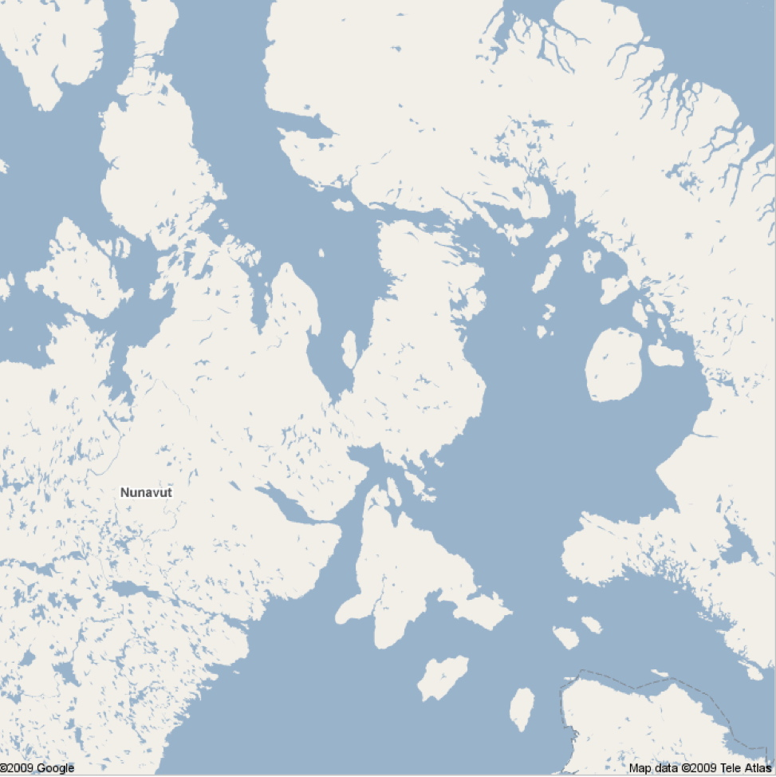

Inuit Have Reasons for Giving Places a Name

What you need:

Elder Stories
Pictures of Places – or made up stories

What you do:

- Begin the class by returning to the map of the island and identifying names of places on the island.
- Get students to try to identify the names that are listed in Inuktitut.
- Possibly seek the advice of your TA or an Inuit fluent teacher to assist with these names, although the elders’ narratives included developed from the final section of this document provide information about each site. The narratives included only describe two or three locations.
- Reading an elder’s story about the naming of places or landform feature. Refer to the examples of naming that are included herewith. (e.g., UGLIARJJUK & ARNARQUAKSAAT). Ask the students what they know about these places.
- Use examples of Igloolik landforms/locations to illustrate Inuit names and discuss why they have these names. Read the attached narratives. Throughout the readings use pauses to ask questions and keep students engaged.
- Ask students if they have any stories about naming, or know of any further significant stories. There is much opportunity here to seek out the full stories about this history through the assistance of people in your community. The stories will be of tremendous interest and importance to your students.
- As a take home assignment, have the students take home a map of the area and pick a landform or named area and find out from an elder or family member or someone in the community the story behind the name. Refer to the following worksheet.

What you look for:

- Do students understand why places have names and why these names are important?
- Are students aware that reasons for naming may be different around the world?
- Can students think up names by themselves?

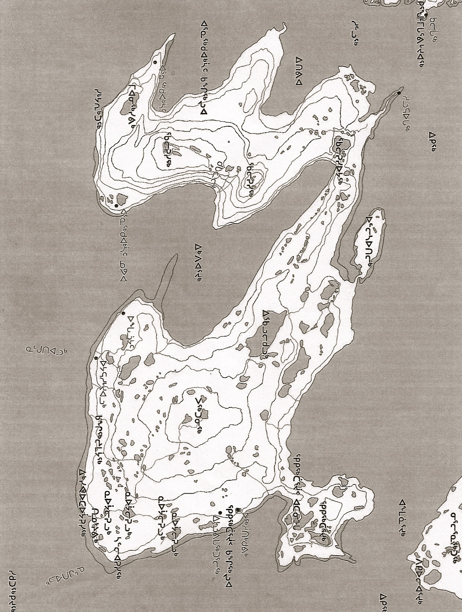

Some Important Places Near Igloolik an adaptation of an interview with Noah PIUGAATTUK /Rosie IQALLIJUQ
There are any places near Igloolik importance to us. They have been special places for a long time.

In the spring time we begin to want to travel more because the sun has returned and the temperatures are warmer. In the spring time there would be people staying at UGLIARJJUK before they proceeded on to AVVAJJA. They would be there while the ice was still good so that the hunters could hunt the surrounding area for bearded seals. It was about that time that is when UTAK and I had made the journey out west that I caught my first bearded seal by (VOC) AURIAQ [stalking]. Our elders were staying on that island in the spring time for an extended period with plans to move onto AVVAJJA as soon as the ice started to show signs of decay.

It is called UGLIARJJUK because that the walruses used to use it to bask in the summer time it was used as UGLIT. There are a few islands that were be used for walruses to bask which of course include the islands UGLIT further south. These

There are old QARMAQ ruins just down on the island. This is where the ARNARQUAKSAAT [Women elder] name is derived from. In those days’ women used to be left in the camps in the spring time while the men hunted. There is a place called UTTUUSIVIK [Place of female genitals] for this reason as well. The main reason of course is that the elders use to be left in these camps while the hunters and their families hunted elsewhere. At the time when hunting equipment was crude they would have to go inland in order to hunt caribous inland, so the elders would be left on the sea edge so there are certain places where they would have had to stay to wait for the return on the summer inland hunters.

This place is something familiar to the modern day old folks home, so ARNARQUAKSAAT was the place where the women elders or men stayed. They were not idle. They had skins to dry on the materials that were brought over to them. So (NINGIUT) [elder women] or also known as ARNARQUAKSAAT use to stay mainly at that place where the old QARMAIT are.

When the women elders were left the hunters made certain that there were always food available to them. These were the places where the people that were no longer active in hunting would be staying, these locations were not picked at random, they usually had places where they would be TINUJJIVIIT usually at a mouth of a stream, with this close to their camp they would be provided with fresh fish.
A Perfect Place for Hunting Walrus: An adaptation of an interview with Noah Piugaattuk

There are many places near here that are very important. Some are known only by a few.

One of my favorite memories is hunting walrus as a child with my family. We had a special place to hunt in the spring that was near the sea. I do not know if other people are aware of it to this day. My father would set up the camp in a quarry near the ice where there was open water and the walrus would come in the early morning. It was a quarry because for a long time people new they could get flints from there in the early spring. The quarry had high cliffs around it so that it was difficult to climb up out of the quarry.

When you stood in the quarry and looked down at the sea you were surrounded by the cliffs except for the opening to the sea. But my father knew it was not only good for flints it was also good for hunting walrus because of the way the quarry faced the sea where the walrus were. We would set up the tents in the quarry and the quarry went all the way down to the ice edge.

This place was very interesting. You would go to sleep at night and in the early morning you could hear the walrus grunting (uurruuq) even though you were quite a way from them. Their grunting would wake you up because it sounded like they were beside the tent. You would wake up with the sound of uurruuq uurruuq uurruuq uurruuq uurruuq uurruuq. It was loud and like they were right beside the tent but they were far away. The place was a place where sounds from the walrus would resonate off the walls of the quarry. The sound was like an echo but louder and right beside you although they were far away. It was like the sounds of the walrus could not escape and would stay in the quarry. It always sounded that there were lots of walrus in the morning when we woke up. My father would go to look while we were still waking up and he would return and often would announce that it sounds like there are a lot of walruses because we could hear their bellowing and grunting sound. But often there would only be one or two walruses. It sounded like many but there were actually only a few.

He would then try to kill them. We were not allowed to make much noise because the same way we could hear them, the walrus could hear us.

Stories from Around the Island; Based on an interview with Michael Kopaq. IE-107

On the north side of Igloolik island there is a place called Ullisautilik. You can tell why it is important to us just because of the name. Ullisautilik.

They used them to get food and the skins for clothes by using these stone traps.

We do not use the island but in the old days, they used an Ullisaut (stone trap). The trap was made of a conical structure of rocks which is hollow inside. It was open at the top and bait was put on the inside. Animals, mainly the fox and a occasional wolf, are attracted by the bait which is placed in the bottom of the trap.

Since they didn't have leg hold traps then, Ullisauts were the only means of getting foxes; that is, if they fell into one of them. There is an Ullisaut on top of the island so that is how it got the name. The island where the Ullisauti is - I think that is the only place around here that has the stone trap. Further down at the point of the hill there is another one and I once saw a fox in that one. I have never seen any other foxes in the Ullisaut even though people used to use them.

I think there might be some right here beside Igloolik.

Another interesting place is another one is Iqalulikuluk. It is the name of the place of a little because the lake contains fish. It is the name of the place, and I bet you, they didn't exert their energy to catch the fish as they would on a weir. I guess they would try to catch the fish only in the spring time.

They would catch the small little fish there. Now in the fall people go there to ice fish. Nowadays, we fish there in the fall but in those days I don't think they bothered fishing in the fall, instead they would fish in the spring.

There are many other places. The places had names because of what we did there and why they were important. The names we use help to describe the place. It tells you exactly what the place is like and what it is for.

You can even picture it if you haven’t seen it.

Like, Ullisautitalik. Iqaluit.

Story of Qikiqtaarjuk: Based on an interview with Michael Kopaq. IE-1The Importance of Names to Inuit: An adaptation of an interview with Noah Piugaattuk
It is really important to know the names of places in our land. They help you to navigate. They tell you where important things are. They tell you where important events happened.

If you have a name for a place, then you can say the name of the place and the person would recognize the name and know; but if there is no place name for that area, then how can a person know where to go? It has to be a name that helps you to navigate.

We hear people from down south say Baffin Island or Melville Island or Frobisher Bay. Those names don’t help you. They have no meaning. They are just dead peoples’ names. Inuit don’t name places after dead people. Inuit names they don't use people's names. They don't use dead people's names.

They name them because of its shape, form, or what had happened there before. With place names there are stories that come with them. For example, let's say, IMILIK, in Inuktitut it means "place with drinking water." This is an important name because it has some meaning to you if you are travelling. There is something important there.

Sometimes we name a place after something that happened there. There is one place I know of. There were three dog teams that went to Greenland in the 70s from Igloolik. There was a place they had to go through, which was called PIRLIRARVIGSSUAQ which means "a place of great starvation." That is something we will ner forget. It helps us to be careful.

Like Hall Beach. Yes, it is a beach but why call it Hall Beach. Hall Beach itself wasn't an established community when the DEW line got there. It was established because of what the army wanted to have. Because the Inuit got there and when they named it Hall Beach, since it was in an area, which is not a very good hunting spot, and they named it for visual means. Then there is Baffin Island, which doesn’t mean much at all. QIKIQTAALUK. That's Baffin Island. That means big island. It means very big island. And near us we have little islands so we would call them little islands; not name them after someone.

And Frobisher Bay, that is better to be called Iqaluit because it has been a good place for catching fishes. There are many Iqaluits in Nunavut.

The Importance of Names : An adaptation of an interview with Theo Ikummaq
Inuit are good at observing the land and then making names based on the descritions This is useful, better than a name from someone that means nothing.

Then if we didn't have place names, you know, a lot of times I've gone to places where I don't even know the names, but then navigation is still the same. Someone tells you a name and it means something so you what to llok for. If you see it you know you are on the right trail.

For example if I'm going in-land and I haven’t been there before, I don't know all the place names there, but then it doesn't mean that I'm going to get totally lost once I get in the middle, but it really helps to know where you are once establish a place name.

The people have shown that most of the European place names seem to be in memory of someone. When the British were first here, although I must say not around Igloolik so much, but in other places, all these English names, Fury and Hecla Strait, Quilliam Bay, Richards Bay, Foxe Basin, none of them really mean anything very much. I mean they're just names whereas people have noticed that the Inuktitut names are descriptive.

You have really a geography there, all this...almost like a map if you like. As far as I know there are not many places names around Igloolik that have been named actually for people? There's one at ANGMALURTUALUK area, there's this lake that's named after a person because that person had been traveling home, got on his qajaq and crossed that lake and then drowned there. That's the only place that I know was named after him.

And the only one I know of is an Inuktitut name after a Qallunaaq that died, UMILIGAARJUK, which is I guess just south of Hall Beach.

Place names, you find QIKIRTAQ, PINGUQ, TASIQ, KUUK, like fishing places for example, KAPUIVIK, MAJURTULIK, and then descriptions of rivers .

IKPIKITTURJUAQ - that's a description of a river. Something less then 100 yards from the lake to the sea so it's IKPIKITTURJUAQ, it's wide but it's short. So a lot of them are descriptive, like QIKIRTAAJUK for instance, it's a small island, it was a small island at one time so they call it QIKIRTAAJUK. The names mean something.

Find out the Story behind the Name

Directions: From your parents, grandparents or someone in the community, find out what the story is behind the name of a place.

Place: _______________________

What is the Story?

Draw a picture of the story?

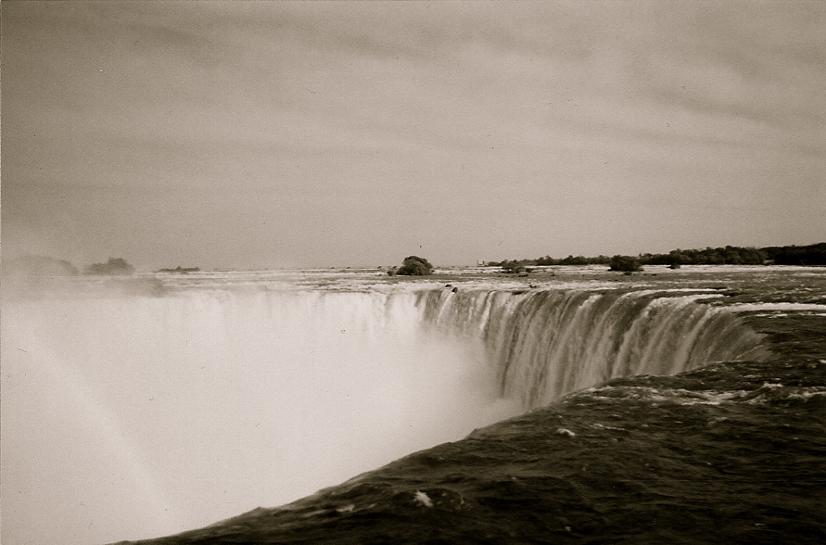

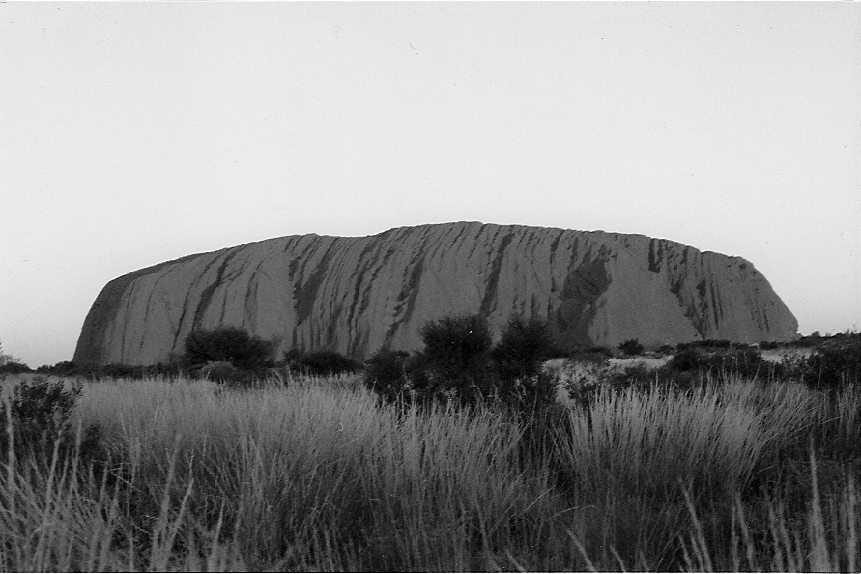
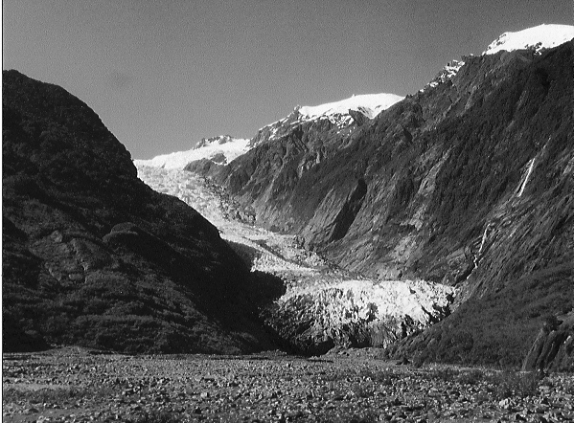
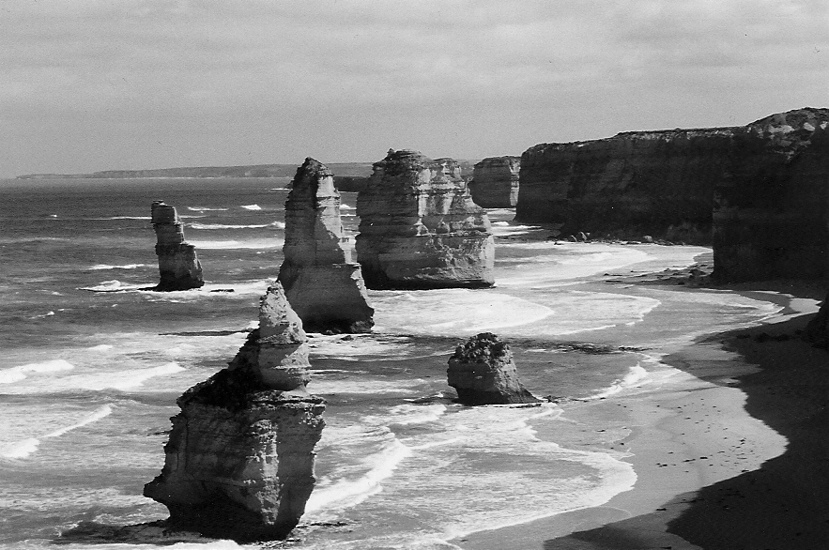
Photos used with permission.
Location is Important to a Community

What you need:

Elder – to talk about Igloolik’s location
Geographical information of Igloolik
History of Igloolik from previous classes

What you do:

- Begin the class by asking students if they know why Igloolik is located where it is now? This may have come up in previous classes.
- Is there a reason for its location? Why do you think that Igloolik is located here? What are the advantages and disadvantages to this location? Ask students to list some off and make a chart on the board.
- Have an elder into the class to tell a story about Igloolik’s location. Have the speaker focus on Igloolik’s current location as well as previous location(s). Is there evidence of settlements anywhere else on the island?
- Using the previous map of Igloolik on the wall, illustrate where Igloolik used to be and allow students to ask questions about the community location moving. Having an elder in the class would be beneficial for having questions answered.
- To get the students further involved with thinking about location, ask them if there are any other locations on Igloolik Island that they think would be suitable locations? Why?
- This lesson may be a suitable introduction to the concept of Igloolik rising. I.e. are the older locations close to the water? How important is it for the settlement to be close to the water?

What you look for:

- Do students understand the importance of location?
- Can students identify the locations of Igloolik?
- Can students identify the reasoning behind Igloolik’s location and the reasons for moving?
Many Towns in Canada Have Names Derived from
Aboriginal Words

What you need:

Examples of places where names are derived from Aboriginal words
A map of Canada with place names

What you do:

- List the names of 5 places that have been derived from Aboriginal words on the board – Aklavik, Winnipeg, Tuktoyaktuk, Saskatchewan, Manitoba.
- Show pictures of each on the board without saying their names.
- Get students to link the picture with the name
- Tell students the meaning of each name
- After discussing the importance of each name and reasons for giving places a name, have students discuss if they know of any further names derived from Aboriginal languages.
- Follow up by allowing students to look at an atlas of Canada and identify towns that may be so derived
- Let students in pairs choose two names and search to find the origian of the town’s name
- Get students to consider why some towns/locations have Aboriginal derived names and some do not.

What you look for:

- Can students identify places on map?
- Can students identify with some justification traditional named locations?

Traditional Inuit Names are Being Restored

What you need:

Examples of places where names have changed back from English to Inuktitut
Examples of other areas around Canada or the world that have also changed names
Old and new maps of Nunavut and the NWT showing town names from the past and currently

What you do:

- Provide students with a photocopy of a map from an atlas of the NWT-Nunavut area from a few decades ago and today. Get students to note some obvious changes, especially with names of towns.
- List, on the chart given, the names of changed towns.
- Get students in pairs to find out the meanings of these English and Inuktitut names through an internet search.
- After discussing the importance of location and reasons for giving places a name, have students discuss if they know of any towns that have changed name.
- Follow up with; why was it named this? Who named it? Why did it change back? Who decided to change it back? When did it change?
- Ask students to provide further examples of communities or places that have changed back to Inuktitut. Allow opportunities to discuss these name changes with the class. An example that may be familiar is Iqaluit (Frobisher Bay).
- Why is it important for Inuit names to be reclaimed? To them, their parents, grandparents, family and culture. If the students are having trouble with this, allow them to ask their family members
- It would likely be useful to illustrate these places as a chart on the board, showing the different names. Leave room on the worksheet for the following activity as well.
- Are there any other places in Canada or around the world that have changed names? Give examples to the class and discuss, i.e. Kitchener, Ontario (Berlin), New York (New Amsterdam), Montreal (Hochelaga, Ville Marie, Mount Royal) Uluru (Ayers Rock).

What you look for:

- Can students identify places that have had a name change and why?
- Can students identify the importance of having traditional names?

Traditional Inuit Names are Being Restored

Inuit places have changed name as well as other places around the world

Current Name Previous or Traditional Reason for
Traditional Names Meaning Change

Iqaluit Frobisher Bay Place of many
fish

Each Community Has an Identity and Its Name is Important

What you need:

Examples of places where names have changed back from English to Inuktitut
Google Earth or Google Maps

What you do:

- Now that we have talked about these places changing their names, its time to look a bit further at them and other towns that have traditional names.
- Using the list of towns from the previous class, specifically those from Nunavut, use Google Maps or Google Earth to go over further information on one of the towns.
- This information could include, but is not limited to:

Location and geographical features nearby
Meaning of the traditional name and English names.
Population, chief resources (game)
- Have students try to identify from the maps and information above, why the community location is where it is.
- Have each student or pairs of students choose a community. Have each student or pair create a poster, picture or model (possibly clay) of their town selected with a description of aspects of importance, especially geography, history, resources.

What you look for:
- Are students becoming more familiar with why names of towns are changing?
- Can students identify the importance of having traditional names?
- Were students able to combine their knowledge from the location lesson and the naming lessons?

Traditional Places – My History

What you need:

Large maps of Igloolik and area
Google Earth or Google Maps
Worksheet

What you do:

- As another transition lesson, looking at the territory of Nunavut and away from only the Island and town of Igloolik, students will focus on their family’s traditional summer camps or homelands.
- This activity will be done mostly as a take home activity. Before instructing the class what to do with the worksheet, and what will be involved for the take home part of the assignment, allow students to tell you what they may already know about their families traditional summer camps or homelands.
- Pass out the worksheets to the class and allow them some time to start it. Instruct them that they are to take the worksheet home and have a family member (Grandparent, parent) or other elder help them find out information about traditional summer camps or homelands.
- Questions about where family members were born, where and when they arrived in Igloolik island, stories about this place.
- When this has been completed. Ideally, the next class, allow the students to share the information they found with the class. When this has been done, place a mark or the students’ picture on the large wall map corresponding to the location.

What you look for:

- Can students identify the traditional summer camps or homelands of their family?
- Can students identify the reasons for the location of the camps?
- Do students have a sense of the short history of Igloolik and changes?

Traditional Places Worksheet

Directions: From your parents, grandparents or someone in the community, find out where your family’s traditional summer camp or homeland is.

Student: _______________________

Where is the homeland / camp? How do you get there?
What is there? Resources/landforms are nearby?

Give a story about this place in Inuktitut or English?

We live in Nunavut

What you need:

Map of Canada with provincial and territorial boundaries.

What you do:

- On a large map of Canada, have fun with students in talking about each of the provinces and territories.

i.e. what is in Saskatchewan? What do people do there? What are the bigger cities or towns? Why would people live there? Who are famous people from this area?
- Possibly give students in pairs a province or territory each and get them to find out one thing that interests them about each place. As an example, famous hockey players, or movies filmed there, or famous landforms, or lakes, or recreation activities, hottest and coldest, largest cities, time joining confederation, size, etc

The following two maps could be used as a resource, one with provincial/territorial labels and one without.
- After a discussion of all the provinces and territories in Canada, have students talk about what Nunavut is to them.
- Ask Guided questions such as;

How long has Nunavut been a territory for? Compared to the others?
How big is Nunavut?
What do people do in Nunavut? On the land and in towns?
What else should I know about Nunavut?
If I were a tourist coming to Nunavut, what are the things that you would like to show me?

- Consider getting students to do a tourist brochure for each of the provinces & territories focusing some of the previous questions. Cut up a Map of Canada and allow students to try to pick one province or territory and this to be the focus of their brochure.

What you look for:

- Are students activating their knowledge about Nunavut and its place within Canada
- Do students have an understanding of the other provinces in Canada?
- Can students describe what they already know about Nunavut?

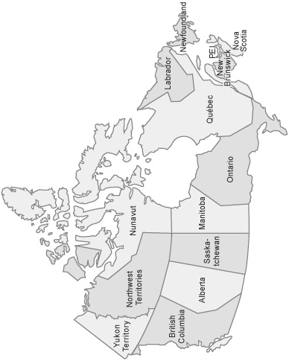

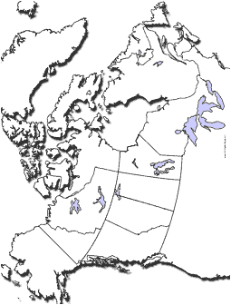

There are similar place names in other areas

What you need:

Elder – with stories of similar named places
Maps of Nunavut
Atlas

What you do:

- Provide students with an atlas of the world. Provide them with time to look at things of interest.
- Get them to locate certain cities or towns in the world
- Let them choose locations individually and then get their classmates to find them.
- Ask students if they know of any other places that have the same names. If not, let students look though the index and locate place names that are found in more than one location – Sydney, Darwin, London.
- Ask students why places might have the same name?
- Ask students about names that have “New” in it – New York, New Orleans, New Port.
- Allow students to come up with places they know of that have similar names. These do not just have to be a town, but any place. Also, they do not have to be exactly the same, but similar.
- Have an elder come in the classroom and tell stories of places that have the same name. Focus on the why names are given, and the difference between Inuit naming and ‘European’ naming.
- Why is it sometimes confusing for places to have the same names? Have the elder talk about this more.
- Are there any other Igloolik’s? Where are they? Can we map them? Show these on the wall maps.
- Make sure students place the locations discussed on wall map.
- Are there any other places in Canada or Nunavut that could be named the same? Give an example or show pictures to engage students. Or ask the students to pick other areas they think could be named similar names to those they know.
- Following this lesson is a story that could be adapted into the lesson.

What you look for:

- Do students understand why some places have the same names?
- Can students place these on a map?
- Can students extend their knowledge to the hypothetical?
- Were students engaged with the speaker?

Similar Names: Based on an Interview with Joe Iyerak – IE-463.

Q. There are some names that are the same in different areas. Can you think of an example?

A. UPINGIVIARJUK, there are a few of them. AULATTIVIK, there are a lot of AULATTIVIK. IQALUIT, there are dozens on Baffin Island.

(Have any of you heard of places by these names, or know where one is?)

Q. So, let’s say you are talking about Iqaluit. How would you make yourself understood regarding which Iqaluit you are talking about?

A: It will depend on whom you are talking to and what you are talking about. If you are talking to a person from Iqaluit, which used to be Frobisher Bay, you only refer to the Iqaluit where he or she lives, not what I know about. There is an Iqaluit in Pond Inlet, and if you are living in Pond Inlet when they start talking about Iqaluit, then the person will know.

What is Nunavut Geographically?

What you need:

Map of Nunavut
Pictures of landforms – i.e. mountains, lakes, peat, glaciers, bays

What you do:

- This lesson depends on weather, but could also be adjusted to suit staying inside.
- Begin by showing students their pictures or other collected pictures of their local area or Nunavut in general. Focus on landform features and words that describe them and the names of the landforms, even their specific names.
- We have done a lot of talking about landforms and physical geography, today we are going to go outside and see some of the landforms and places that we have talked about. Explain to the class that what we have been talking about with landforms is called physical geography, and that we are going to go see what physical geography we can find around town or the island.
- With teacher supervision and again, hopefully a Teacher Assistant, students will go outside to find as many examples of the physical geography as they can. Have students show you all different types of rocks, soils, outcroppings, hills, beaches, etc. Start off with obvious things that have been talked about in class. This will be dependant on time, but just around the town, students should be able to find quite a variety of different ‘physical geography’.
- Focus on elevation differences, where there is a steep or gradual shoreline, where there are large and small rocks, moving and non-moving water, sands and sediments and plant material, where houses have been built and have not been built.
- Have the students keep track of all of the items that they located on the following log sheet to work on later.
- Once they are back in class, get students to draw an illustration or, better yet make a model of their community detailing the geography of the area but eliminating the man-made structures. They should make the model as authentic as possible by using materials to duplicate these structures, especially plant and earth materials and the topography of the immediate community.

What you look for:
- Can students identify landforms from previous classes?
- Do students understand the concept of physical geography?
- Can students find different types of physical geography and where?

What Physical Geography Can We Find Around Town?

What is it? Inuit term? Where was it? Found elsewhere?

There are Different Landforms
Found Around Nunavut

What you need:

Pictures of landforms/rocks/geology from around Igloolik and Nunavut
Worksheet from previous class, extra worksheets.
Maps
Worksheet – list of features for a scavenger hunt

What you do:

- With the worksheet from the previous class, go through the list that the students were able to develop. Ask the students if that type of material is found anywhere else on the island. Also ask if they know if it is located anywhere else in Nunavut. On other island? If so, where? Also ask if they think that it could be found anywhere else in Canada.
- The large maps of Igloolik, Nunavut, and Canada from previous classes still should still be available to use as a reference for this activity.
- When the list of objects from the previous lesson is complete, have pictures of other landforms and physical geography from around other parts of Nunavut available. Go over these pictures and ask the students if they know where they are found? When it has been discussed, they could be pinned or taped to the map.
- A fun way to modify this activity would be to make or draw the objects. If each student had molding clay or something similar, they could try to make the objects. Drawing the objects would also be a good way to see how the students see the objects.
- Some examples could be from Baffin Island, Glaciers, Fjords, Melville Island, Innuitian Mountains. It is important for the students to try to come up with the proper Inuit term for these landforms as well.
- Have students add these terms to the worksheet list from the previous class.
- Another fun activity for the students, which will also help test knowledge, is to have a Landforms Scavenger Hunt. Following this lesson is a map that could be used for this activity. This activity could be accomplished as a lesson in itself. Again, this would allow students to use all of the worksheets from previous classes. The teacher should develop a list that outlines the landforms (or features) that are most important.
- On a worksheet, the students should be able to give the common name of an item on the list (ex. Give the name of a peninsula). The students should then try to find the Inuit name and/or meaning for this, and locate it on a map.
- This can be repeated for a list of ~10 features (bay, island, mainland Canada, sea, lake, river, fjord, mountain, isthmus, point, passage, strait, ocean, glacier). The students could work individually or as a group for this activity.
- The maps given as an example are specifically for Igloolik and area of Nunavut surrounding Igloolik. Maps could be adapted to show a much larger area or a more localized area.

What you look for:

- Are students aware of different landforms, where they are found and what they look like?
- Have students developed a sense of the different landforms that make up Nunavut?
- Can students recognize the Inuktitut and southern terms for geological features?

Map: Scavenger Hunt

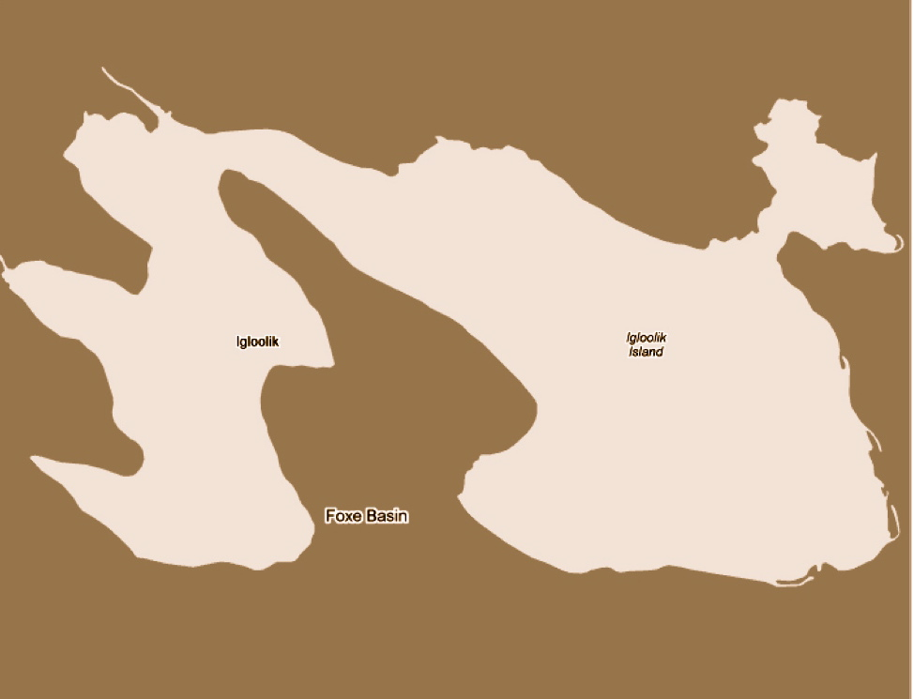

These Landforms are a Part of Larger Landform Systems

What you need:

Map of Canada with the main structural units of Canada outlined on it

What you do:

- How students pictures from different parts of Canada – plains, hills, mountains.
- Begin by asking students why they think there are similar landforms or features across much of Nunavut. We showed in the last classes that some of these objects are found all around Nunavut and some in other areas of Canada.
- Show students pictures of different places in Nunavut. Ask if the geography is the same. What are the similarities? Differences?
- If students are not sure about this, ask them if they think the ground under them is the same all across Nunavut. Why do they think this? Are their examples that make you think this? Why are their similarities across Nunavut/Canada, and why are there differences?
- Show a map of Canada with the main structural units on it and explain that it is because there are three main systems in Nunavut, the Canadian Shield, the Innuitian Mountains and The Arctic Platform (lowlands).
- Explain that much of the features around Nunavut are similar because of the Canadian Shield. Take time to explain what the Canadian Shield is and how it came to be. It is important to explain the expanse of the Canadian Shield, so that they understand that this is why there are similar landforms in other areas of Canada too.
- Also explain the Arctic Platform and the Innuitian Mountains. Explain that this is the reason why not all of Nunavut is the same. To help students picture this, give examples of what students would find if they were to dig beneath the soil of these places. Or what is the difference between the shield rocks and the Innuitian Mountain rocks?
- Ask students if they have any other questions about the systems or others that are on the map from around Canada.
- It would be useful to have lots of pictures to use as reference during this lesson to help keep the students engaged.

What you look for:

- Can students recognize the concept of there being different structural systems within Nunavut, and Canada?
- Are students aware of the three structural systems? And their different properties?

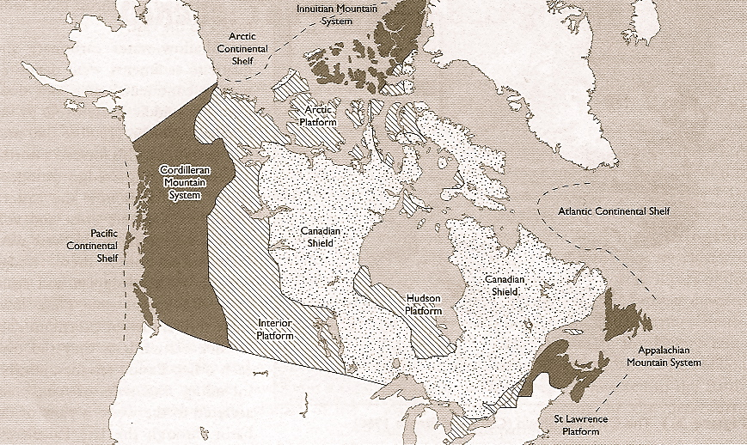
Source: Geomorphology: A Canadian Perspective 2nd ed. 2004, p 32.

The Glaciers Also Caused Some of the Landforms

What you need:

History of the glaciers
Evidence of glaciers around Nunavut
Map of the Glaciers

What you do:

- Begin by showing students a map of where glaciers are in Canada today.
- Show students pictures of glaciers from Nunavut, especially the Qikiqtani region.
- Ask the class if anyone knows what the glaciers are doing in terms of size? Are they growing or are they shrinking? Show a current map of where the glaciers are now.
- This could be done as an overhead projection and then have students transfer to a larger map on the wall.
- If students recognize that the glaciers are shrinking (possibly through their knowledge of global warming). Follow up by ask them if they know how big the glaciers used to be. Similarly, ask the students how small they think the glaciers are going to get.
- When the students have tried to guess how big the glaciers used to be, ask them if they think that glaciers ever covered igloolik before? How do they know, why do they think this? Have them show on a map where they think the glaciers used to be, compared to where they are now. Using one of the previous maps of Canada would be good.
- Go into the history of the glaciers, and show the students how far the glaciers expanded at their peak. Showing a physical map would likely be the best, where the extent of the glaciers is shown. Timelines of the glaciers might also be helpful. Allow students to ask lots of questions.
- Explain how the glaciers moved, and give examples of what happened to the ground underneath when the glaciers moved. Explain that this is why there are some landforms that are the same, that were caused by glaciers. Give examples.
- Get students to think about how the sea-ice moves along the beach in spring and how it can eat away at the beach. Get them to think about what huge, thick glaciers would do to the ground below.
- Maybe consider how you could model the impact of glaciers moving across the earth long ago or even today in the Qikiqtani region.

What you look for:

- Can students identify how the glaciers affected the area and all of Nunavut?
- Can students understand the concept of the glaciers growing and shrinking over time?
- Are students able to use their current knowledge about glaciers?

Glaciers in Canada today
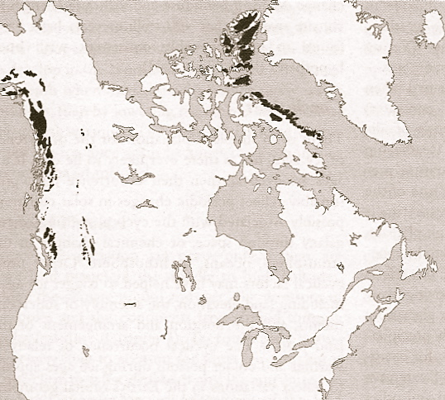
Source: Geomorphology: A Canadian Perspective 2nd ed. 2004, p 182.

Extent of Glaciers 18,000 yrs ago
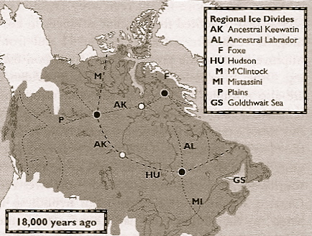
Source: Geomorphology: A Canadian Perspective 2nd ed. 2004, p 191.

Igloolik Rising?

What you need:

Elder story about Igloolik rising
Historical Data
Map of Igloolik – Preferably a topographic outline map
Foam or sponge

What you do:

- Following the discussion on glaciers, ask the students if they think that the Glacier affected the island. How might it have affected Igloolik?
- With a piece of foam, sponge or similar material, demonstrate to students what happens when a lot of weight and pressure is placed on an object and then removed. Do they think this could happen to the land when the glaciers were over top? This would be a good opportunity to reiterate the size and thickness of the glaciers.
- So, if the glacier was above/around Igloolik, what might be happening to the land?
- Ask students if they can think of any ways they can see or stories they know of that show that Igloolik could be rising? I.e. inland campsites that would have been near water some time ago.
- What else? Qikiqtaarjuk – Little Island. Why is it called Little Island if it is connected to Igloolik? Isn’t it more like a peninsula, not an island?
- Read students the elder story of Qikiqtaarjuk.
- Propose that Qikiqtaarjuk used to be an island but isn’t anymore because the land is rising. Why else might Qikiqtaarjuk not be an island anymore?
- Look at the elder’s story provided in the elder’s story that folloed. Within the Igloolik regions this story of the ‘island’ which is now a peninsula is of great interest to many people as it either provides evidence for the island rising or the water rising.
- Follow up by asking the students if they can think of any other examples. Inland campsites? The Inuit like to have camps near the water, why would there be inland campsites?
- Activity – Hand out a map of Igloolik to each student, outlining the topography. Have the students to shade in the areas that they think might have been under water at some time. What do they think Igloolik may have looked like? This could range from not long ago, to very shortly after the glacier receded over Igloolik. It is not important for students to have the right answer, but for them to have an understanding that Igloolik is bigger than it used to be and could be rising. Alternatively, could also have them try to show what Igloolik would look like it keeps rising.

What you look for:

- Do students understand the affect that glaciers have had on the landscape?
- Can students understand the concept of Igloolik rising?
- Were students able to think about what Igloolik once looked like or could look like?

Qikiqtaarjuk is no longer an island even though its name neans it is an island.

You can walk on it now which makes it a peninsula. If we were archaeologists, we would be able to find artifacts on the top - only on the top. It must have been an island before. Once, a person was left on the island, this is the legend. Today it is no longer an island, but when the person was left on the island she could no longer make it to the main island.

A couple had a daughter who didn’t want a husband. She wouldn’t take any human being for a mate because apparently she had been having a dog for a husband. The father found out that she had been seeing a dog, and she wouldn’t have anything to do with any man. The father got angry with his daughter for this and she became pregnant. The father took his daughter and the dog to the island.

They lived there. The father figured that he should support her but he lived across from the island. The dog would swim the channel between the two islands to get food and meat that the father supplied. The father got tired of supplying food to the dog. The father put sand in the bag that the dog carried and as the dog crossed the channel he drowned from the weight of the bag.

Since the dog drowned the woman and her children had no one to support them.

Having no support there was an old shoe from a kammik. When a shoe from a kammik is dry it is hollow inside. Taking the shaft of the kammik off, she was left with the shoe. She told her children to find a " Saiqqut" and using the shoe, she put her children in the shoe and sent them off to sea. They were small children. Using the shoe of the kammik she sent them adrift.

So the daughter of the man was left all alone. When she became a widow, he took back his daughter. Taking her on his kayak, they headed towards this area, and I'm sure it took them more than a day to get here. After they had settled down for sometime, a man arrived to claim the woman for his wife. He wanted to marry the woman who didn't want men.

Making a Model of Igloolik Island

What you need:

Paper, glue, plaster of paris, paint, paper and glue for paper mache,
cardboard or other medium to build a topographical representation

What you do:

- A significant amount of time has been spent describing the features of Igloolik and area, with the previous lesson focusing on the topography.
- To help students visualize further the topography and shape of the island, the class will get the opportunity to build a model representation of Igloolik.
- Using the medium of the teacher’s choice, instruct the class of what they are going to be doing. This activity can be done individually or as a pairing. The students will need to use the maps from previous classes to help create a picture. Note that on the picture given there are place names and contour lines. Each contour line represents 10 m of elevation so that if students build a model they need to ensure that they use a scale that makes sense. They may need to make an OHT of this and project it onto large paper first and then work from there. As an example, if they use thick cardboard of 3-4 mm thickness for an island about 30 cm wide, they will end up with quite a realistic model.
- Because we have focused so much on the area around Igloolik as well, students may want to include the water and some of the surrounding smaller islands. The main focus should be on creating contours and elevation that closely represents Igloolik.
- If time permits, students may want to paint their models or highlight the town and add flags with brief stories to label areas of significance.

What you look for:

- Are students able to take what they have learned over the previous classes and create the image in their head?
- Can students build a physical representation of Igloolik?
- Were students able to finish the project or will more time be needed?

Igloolik and Nunavut are a Part of the Whole World

What you need:

Maps or Google Earth
Smart board if available?
Access to the Internet
Projector

What you do:

- As a transition into this lesson, some time could be spent on how the ice age and glaciers affected other areas of the world.
- To activate student’s knowledge, ask students to think of ANY Cities or place that they have heard of from around the world?
- Have each student write down two places. I could give examples but would prefer not to, and let them come up with their own.
- Have students look at Google Earth and observe its location. Get students to get a sense of shy this place is located where it is. How does geography effect where people live?
- They should divide a page in half and draw the location of each city suggesting why it is where it is.
- Share their cities or places with a partner and discuss with their partner why they chose and what they learned about the cities or places.
- Once they have had time to chat with a partner, have each student share their cities or places with the teacher and the rest of the class.
- Make a large list of these places on the board.
- Using Google Earth if available, or a projector, show where these cities or places are located with respect to Igloolik and Nunavut.
- How far away are they? What country/continent are they in?
- Show pictures of these places if there are any available on Google Earth or a quick internet search.
- The purpose of this is to have the students’ think of their own places to activate their individual knowledge and place it into context by using google earth to locate where it is. Google Earth is not a must, but is a helpful and a good way to look at the earth and where places are
Located and infer why they might be located where they are.

What you look for:

- Can students recognize where they are in relation to the rest of the world?
- Are students aware of where the places are that they have heard of?
- Were students able to come up with a place on their own?

We Can Learn About Places Around the World

What you need:

Pictures and stories of other places
The History of a few places
Project booklets

What you do:

- Introduce the class to some cities from around the world by showing further aerial photos or distinct natural or man-made landmarks. These cities could be the same as ones that were generated the previous class, or just basic examples that the teacher feels would be helpful. Tell the students some details about the cities that would fall under the same categories that were used to learn about Igloolik and Nunavut. Such as location, population, physical geography.
- Possibly tell stories related to events about these cities/places.
- Map these areas using Google maps or Google earth. Also discuss why the cities might be located where they are. This relates to a previous lesson where students used google maps/earth to discuss location.
- Based on what they know and can see from pictures of these places, allow the students to come up with Inuit names for them.
- Make sure students tell why they would give this name.
- After a few examples, introduce the project to the students. The class is going to be working on a project to learn about cities or places from around the world. Each student will be allowed to work on his or her own city/place, or work with a partner if they’d like. Students will do research about the city/place that they have chosen. Students will present their project to the class when it is finished.
- Allow students time to brainstorm different cities or places. Allow them to look at maps, etc, and ask lots of question. It is hoped that the class will be able to brainstorm enough ideas that each person will have a different city or place to present.

What you look for:

- Are students able to associate what they learned about naming in previous lessons with naming of cities or places around the world?
- Do students understand what the project is going to be about?
- Were all students able to come up with a project place?

What Can We Find Out About the Names of our Project Place?

What you need:

Access to the Internet or Library
Computers for students, for each student or group
Project booklets

What you do:

- Allow students to finalize their place. After having time to think about it a bit, if they want to switch that is ok. Also, after doing a little research, they may want to choose a different place, but make sure the class knows that they need to have a project place chosen today.
- Have students find out what the name of the place they have chosen means. The following will be a part of the project booklet for the students to fill out. (Page 2)

Does the name mean more than one thing?
What was it named for or after?
Has it always been this name
If it has changed, why did it change?
- Have students pick an Inuit name for their place.

Why did they pick this name?
What does this mean?
- At the end of the class have students share their place with the class and share what the Inuit name is.

What you look for:

- Are students relating their current knowledge to their project?
- Are students able to make an Inuit name for their project place?
- Did students complete the relevant section in their project booklet?

There is ‘Geography’ to your Project Place too.

What you need:

Computers, library, access to books, encyclopedias, google earth if available
Project booklet

What you do:

- Inform students that this class will be used to do further research, and finding out further information on the geography of their project place.
- By completing the relevant section of the Project booklet (Page 3), the students should try to find out;
Where it is located; Country, Continent, GPS coordinates. Longitude & Latitude?
How many people live there? What do people do there?
What type of land are they on, i.e. shield?
What are the landforms that are near or are important to the area?
How far away is their Project place from Igloolik?
If google earth is available, have the students map their place so that they can show how to get there from Igloolik.
- Using the internet, have students find pictures of their project place. Students will be encouraged to save some of the pictures that they find to be a part of their presentation.
- On the following page of the Project booklet students can start working on the similarities and differences between their project place and Igloolik.

What you look for:

- Can students research information?
- Can students work independently, or with minimal teacher supervision?
- Are students becoming ‘involved’ with their project place?

There is an importance to the location of your
Project Place.

What you need:

Project booklets
Information as an example, i.e. Winnipeg
Access to research mediums; internet, books, etc.

What you do:

- Remind students of when we learned about the importance of Igloolik’s location. Have a small discussion about this to activate this knowledge. Review why Igloolik is where it is.
- Ask the students to think if there is an importance to the location of their project place. Before doing any research, have students begin a KWL worksheet (in the project booklet). Have them think about what they already know about the importance of the location and what they want to know about the location of the project place.
- Give an example to the students that you have prepared. For example, Winnipeg or my hometown. Talking about the geography, history, meaning of the name, alluding to the importance of location.
- Allow students the time to research the reasons for the location of their project place. If their project place is not a city, adjustments may have to be made. I.e. why is the border where it is? What are important locations within their Project Place?
- On the KWL worksheet, have students finish by completing what they learned. Have them describe how the location relates to the geography/geology of the area.

What you look for:

- Did students use their previous knowledge of Igloolik for this exercise?
- Can students relate location to geography?
- Can students understand the importance of location?
- Did students complete the KWL worksheets?
S
What are the Similarities and Differences between Igloolik and your Project Place?

What you need:

Project booklets
Access to research mediums

What you do:

- This would likely be the last day for the class to do research and work on their Project.
- The focus for this lesson is for the students to come up with as many similarities and differences between Igloolik and their Project Place as they can. Many of the students may have already begun this page of their project booklet. These similarities and differences do not have to be 100% relevant to what we have been focusing on.
- The students will likely have no problems finding a lot of differences. However, after trying to relate back to Igloolik throughout the unit, students will hopefully be able to come up with some interesting similarities.
- If students are having trouble with this, have an example prepared to go over with the class. For example, Winnipeg or the teacher’s hometown.
- The class following this is the presentation class. However one more class could be given to allow students to prepare/finish their project booklets, get more information for their presentation, practice their presentation, or get pictures to the teacher to prepare for presentations.

What you look for:

- Can students find similarities and differences between their Project Place and Igloolik?
- Did students complete the similarities/differences page in the project booklet?
- Are students prepared for the presentations?
Present the Projects to the class!

What you need:

Project booklets
Projector to show pictures
A picture of each student
Large world map on the wall
Time

What you do:

- Allow students to share all of the information they have found on their project place. Each student will have an opportunity to present their project books and the information they have learned, along with pictures of their project place if they desire.
- On the last page of the project booklets, each student will keep track of all of the presentations. It is intended that this will help the students pay attention to all of the presentations. To show that they were listening, the students are to come up with at least one question that they would like to know about each presenter’s Project Place.
- Encourage the class to ask questions when each presentation is finished.
- When individual students are finished sharing their project, have each student pin up their picture at their Project Place on a large world map.
- If marks are required, students will hand in their project booklets when their presentation is finished.

What you look for:

- Have students finished their project booklets?
- Did each student present his or her project place?
- Were students able to come up with questions for each presentation?

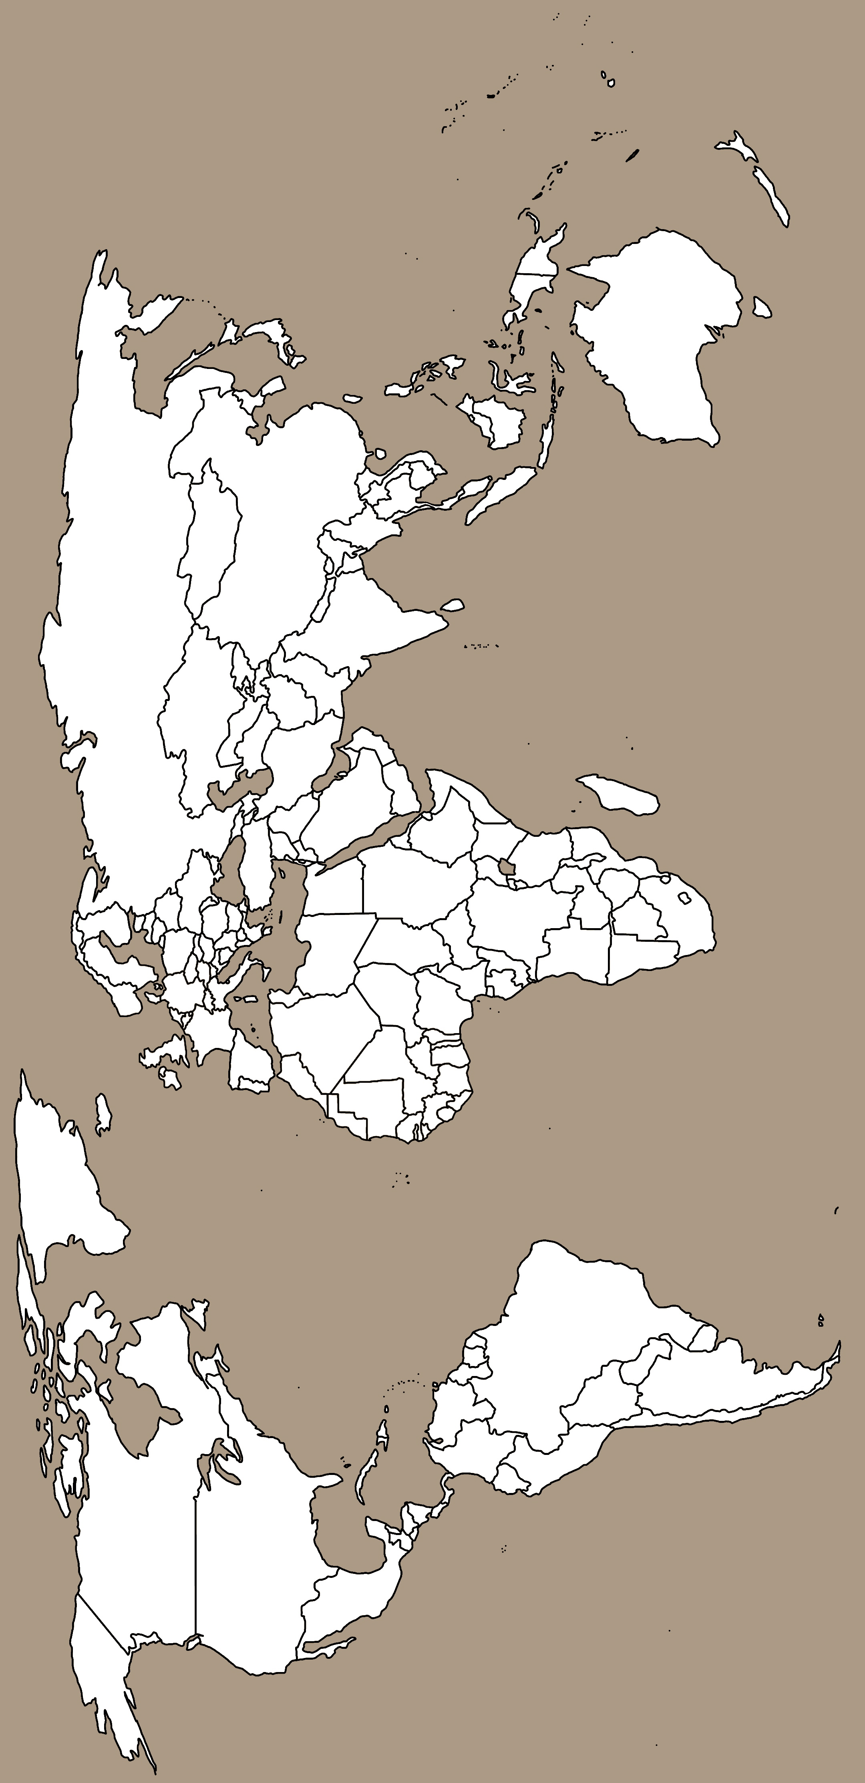
Around the world

Project Booklet

Name: ________________

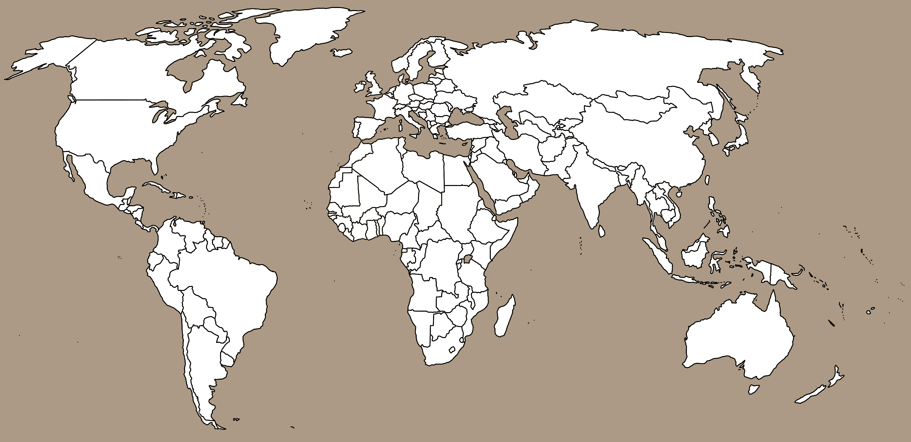

What is my Project Place?
Pick an Inuit name for your Project Place:

What does the name mean?
What was it named after?
If it changed, why?
Has it always had this name?

Why did you pick this name and what does it mean?

_______________________________________________________________________________________________________________________________________________________________________________________________________________________________________________________________________________________________________________________________________________________

FIND OUT MORE ABOUT YOUR PROJECT PLACE
Where is my Project Place located?
How many people live there?
What do people do there?
What are some landforms that are near or important?
What is the Physical Geography?
How far away is your Project Place
Country:
Continent:
GPS coordinates:

SIMILARITIES DIFFERENCES

The Importance of Location

What do I already know?

What do I Want Know?

What did I Learn?

Questions for classmates’ presentations
Name Project Place Questions

Elders’ Interviews from Igloolik

Computer File: IE-463
Tape Number: IE-463
Interview with: Joe Iyerak
Interviewed by: Claudio Aporta
Date: December 1, 2000
Word Processed by: Claudio Aporta

This would be useful for a story on the use of landforms for navigation, especially during the day.

When you travel, usually you travel in the same direction at certain times of the year. And I usually use TUKTURJUK, because it can point you to the North star. And in this latitude the North star does not move as much as the other stars, mainly because it looks like it is in the center, and all the stars are moving around all night. And sometimes when you head south you will see a group of stars that are there all the time. And some stars earlier in the evening will be higher up, and then move towards the horizon as the night goes… or move to the right. But you can always see the stars if it is clear.
Q. Do you know the names of those stars?
A. I don't have the name.
Q. But you have an idea of the relative position of the stars.
A. Yes, and if I know which direction they are moving I will know not to turn when I don't have to. Since they are moving right all the time if I follow the stars I will end up somewhere on the right. So I will set my bearings on the left because stars will be moving all night long.
Q. Do you ever use stars as the main navigational aid, or you also use other methods?
A. In the daytime I usually use landmarks that I know of; that if you can see far enough. And some times on the trail you will see markings that you see all winter, that are there all the time. Like a piece of wood, or a broken qamutiik, or a broken skidoo… All things like that that you have to keep memorizing. If the visibility gets poor and you can only see a few feet away, these little things start to help you quite a bit.
Q. What other landmarks do you use?
A. Inuksuks, or the shapes of the land, rocks. At night you can see where the open water is. It is darker the area where there is open water, which is mostly on the southeast or east of this area. Then on the west you will usually find daylight; the last dusk and damp that daylight will linger for quite a while. If it is really clear it will ling around for quite a while. In early spring you can always see where the sun is or where west is because of that thing; or the darkness of the sea.
Q. Going back to landmarks, about the use of rocks. Do you also memorize the position, shape and color of the rocks?
A. Yes you can, but since we have limited daylight for at least three months; you can have only two hours of daylight in a day for at least a couple of weeks. Colors don't matter anymore because it is either blue or black. It is all gray matter. But in the summer time and in the spring time, then you can start using colors, because it is brighter.
Q. If you have to tell another hunter where a particular location is, let's say a fox trap or a broken skidoo, without using a map… What kind of indications will you give?
A. If there is land close to the thing that you want found, then you will mention the name of the place, if it has a name. But if it is a big island or a point on the land, that is not enough. You have to tell them what there is there that will make it find whatever needs to be found. It has to be a bay, an inlet, a piece of rock, or iceberg if there is such a thing close to that.
Q. Would you also use cardinal points to position the object?
A. Yes, very much so, because, we have names for the four directions of the wind. Like NIGGIQ, the south, or UANGNANGANI (the north), or AKINNANGA, which is west, or KANANGNAQ. But there is also things you can say like QITINNAGANI , which is "away from the shore."
Q. The snowdrifts. How do you tell the difference between the different kinds?
A. If you know where north is. If you have a general idea where north is, then you will see that the ones made by the prevailing wind are pointing toward the south [note: they actually point Northwest], with the UQALLURAIT pointing south [northwest]. And they will be usually harder than recent snowdrifts. And the ones made by the prevailing wind will outnumber all other information that you see on the snow. And the ones made recently by other storms will be usually on top, and soft, and they won't form as well as the ones from the prevailing wind.
Q. So the UQALLURAIT will always point…
A. The tongue on the south and southeast. And the smooth side facing Northwest. [Note: there seems to have been some confusion about the use of cardinal points]
Q. Can you get confused by, the different snowdrifts?
A. Oh yes, very much so. Towards the spring they are more profound. You can see them more because they have built up during the winter months. And sometimes you have this very round shape ones, ULUANGNAIT, "like a cheek." I haven't really learned as much about those as I have with the other, and I am not particularly knowledgeable about that other type of snowdrift.
Q. When we met some time ago in the cabin around Mogg Bay, a few days later you had to help someone with a broken skidoo… What was his name?
A. Lukie Airut?
Q. Yes. I think I remember you told me you were confused that time by the different snowdrifts? Is that correct?
A. At first we went just following a trail and getting a general direction of where it was. And when we got to that place I positioned my GPS so that we could go back to where we started from, and it was alright going in but then Lukie Airut decided that it [the trail] was too stiff to use when there is a storm, and he had caribou and other things that we had loaded in our return trip and he wanted to go another direction, which it was out of what I had recorded in my GPS. And it was already dark and he had decided to use this other trail. And the wind was from the southeast. And going down that slope there were hills and there were rocks, and we only could see a few feet away. To me, it looked like the wind was changing every few hours, and since he was the elder we were following him. We were not using any of our instinct; we were just following this guy (laughs) because he was the oldest of our group. And only when he had come to the lake where the cabin was, he asked me to take them to the cabin, because with my GPS I could go right to the cabin. But if we hadn't used it we would have guessed and used the coast to get to the cabin.
Q. What is the elders' opinion about you using GPS?
A…
Q. Do they laugh at you, or…?
A. No, no, no. They think that's great because we can go there right away, because guess work, or without actually thinking about it, we will use the GPS to go wherever we want to go. You go straighter and you go there quicker. When there is no hills or no open water in between. When you use a GPS you have to know if there are hills in between or open water. Otherwise it is dangerous. It is very dangerous. You have to know where to turn.
Q. So the GPS by itself does not help so much?
A. No, it doesn't help so much. If it is a long distance and there are hills or open water in between.
Q. You are not afraid of losing some traditional knowledge because you are using a GPS…
A. No. It enhances what I already know.
Q. How about younger people?
A. Younger people… they won't even want to rely on … well… I don't know. It is different for each individual. Because of the way they have been brought up; and the way they learn will be different from how another person learned what he knows.
Q. You have been talking about different generations, and how, in a way, an older generation was more knowledgeable than yours. You went to boarding school in Chesterfield. Do you think that that affected your learning process about navigation? Or it didn't affect it at all?
A. My education really affected the way I spoke to my father, because he didn't have that kind of education. And sometimes what he taught me I knew it wasn't right, it wasn't correct. For instance, not my father, but an older person, would tell me that the sun is going around the earth and the moon is doing certain things, which I learned in school were not so. But the knowledge they learned about that was implanted in them, and then you try arguing that, but since you are younger and you are told to respect your elders, then that conflict is always there, not only in that perspective, but in other situations too that you start seeing conflicts with your parents and your elders.
Q. Is the same happening now with younger people?
A. The older generation is moving further and further away as new generations come in, and only until the oldest generations are gone… let's say for me, for instance, if I become an elder, then I will have a better understanding than what my grandfather would have.
(Silence)
Q. OK. A practical question, how would you use snowdrifts to go from Hall Beach to Igloolik?
A. OK, I know the snowdrifts are from the northwest, and Hall Beach is a bit that way (pointing south). Then, you cut them across (he shows with his hands) to go to Igloolik, rather than going with them.
Q. So they are like a compass…
A. Yes, like a compass, yes, but stationary; it doesn't move. It is always in the same direction. However far you go. You can go from Igloolik to, let's say, Rankin Inlet
(SIDE ENDS)
Q. Can you tell me in which situations you use GPS?
A. I will use GPS in cases where there is a storm, and in the summer time, when we start traveling by boat, it can get foggy. And in those cases I would use my GPS to point certain directions. I use waypoints, because we are traveling by water and sometimes land will be in between where I am coming from and going to, and I will usually know, getting close to an area, where I should turn.
Q. You use both GPS and a map…
A. Yes, I use both. But I only use maps when I am trying to go on a trip…
Q. You were talking about open water. Will the open water be a waypoint in your GPS?
A. No, it won't be. That's in my head. But I will use a point of land as a waypoint.
Q. How about caches?
A. Yes, I have used that in one instance where we left some meat to get later on. Or if I left a skidoo, or a Honda somewhere, then I will enter that into my GPS.
Q. Anything else you want to add about GPS?
A. No.
Q. About the ice conditions. Have they changed throughout your life, or according to what you have heard from older people?
A. Yes, they have changed. I know now that the ice is melting quicker than it did in other years. It is not freezing over as fast as it did. And there are more storms now than I remember from other times.
Q. Does that affect your traveling?
A. Yes, it does. Very much so because we live on an island and in order to go to favorite hunting spots we have to go through straits, and channels that are open throughout the year.
Q. So you have to change your trails?
A. The trails are the same, but the timing is different.
Q. The trails are always the same?
A. Mostly always the same because you are usually going to the same general area; to your favorite hunting spot.
Q. Do you think your parents and your grand parents used the same trails?
A. Yes, we are still using the same trails that they have been using because they were using them, and we were told where they are so we still use the same trails.
Q. And, presumably, those trails, on the land, will go through places where traveling is quite smooth?
A. Yes. For example going to Repulse Bay, we still use the same trail that the priest and other foreigners used when they used to come to this area. They were taught by people of that time.
Q. And that knowledge has been passed from one generation to another?
A. Yes, it has. The trail will try to avoid rocks as much as possible because when they use dog teams to travel they had earth soil runners, caked with ice, and rocks will break that. So all the trails, the general trails, will try to avoid rocks as much as possible.
Q. You are saying that in the land the trails are pretty much the same. Is that the case with trails on the sea?
A. They are in the same general areas going to same general direction.
Q. The open water is always in the same…
A. Always in the same area, year after year.
Q. The same with cracks?
A. The same with cracks. The general cracks… you have certain cracks that are there all the time mostly in the same place. And you have other little cracks that will form but then will disappear. But there are cracks in areas that are always there, year after year.
Q. And those cracks are usually good for seal hunting?
A. Yes, the seals would use that all through the year. It opens and it closes, opens and closes all year round because of the ice freezing and forming all the time.
Q. I know you have used dog teams, and I wonder what are some differences between traveling by dog team and traveling by snowmobile?
A. Traveling by dog team, your dogs are ahead of you all the time. If there is a trail they will follow the trail toward any general direction you are going to, and you actually really don't have to do very much, unless you are going through an area where there are no trails. The dogs will know the trail if it is a marched trail. If it has been used, but the dogs some times can remember certain areas where I have been to year after year.
Q. Will the dogs tell you something about the ice conditions?
A. No, they will not. If the ice is too thin they won't avoid that. They will go to where they are commanded to go to, and the driver will have to know if he is going into a thin area.
Q. Do you think the speed of traveling by skidoo limits the way you perceive the land? Maybe you won't be able to pay attention to some landmarks, or it does not matter how fast you go?
A. Yes, if you are traveling at night or if you are traveling fast you are only looking right in front of you. You are not looking sideways or anything. But with dog teams you are always looking sideways, always, always. Not only at the front.
Q. So will you know better the land if you travel by dog team?
A. Yes, because you can memorize all what you have seen and if you go one direction you will have memorized what you have seen already and then when you come back you will know how it was.
Q. When you were a child or teenager, were you taught while traveling on the sled? For instance place names?
A. Yes, very much so. Not only the person I was traveling with but also other people will always mention names of places.
Q. Do women know how to find their way around on the land?
A. Yes, absolutely. Because they are usually on the qamutiik, and they always have a better view almost, some times, of the surrounding areas. Also they have favorite places that they want to go to, with stories, and they will actually teach their children the names of the places, without the children actually going to wherever she was before.
Q. Before the beginning of the interview you were saying that sometimes you would hear descriptions of the land, and it is like you have actually been there…
A. Yes, if you hear them enough times, yes.
Q. So you could go to certain places that you haven't been to.
A. Yes, only by certain descriptions that was made to me. Special markings on the land or things like that.
Q. Have you been lost?
A. Yes, I have.
Q. Badly lost? Like, you didn't know where you were?
A. No, nothing like that. But I have been lost and I have walked home because I run out of fuel before getting to town or because my machine had broken.
Q. But in those cases you where not really lost, because you knew where you were…
A. I knew where I was, but I didn't really know which direction to go to get back home.
Q. So how did you find your way?
A. One time that I did really get lost when I run out of fuel… the glow of the town (laughing) I could see glow of the town.
Q. So that's the way you found your way.
A. Yes, that was the way I found my way back.
Q. How were the weather conditions when you got lost?
A. There was poor visibility. It was snowing, and I was on very, very bad ice. Pressured ridge ice. It was broken ice all over the place; there was old ice from the year before; all packed up.
Q. Have you hear stories about experienced hunters who had got badly lost?
A. Oh yes, absolutely. There is one I know of. It was these two young guys; they went caribou hunting, north of Igloolik. They got to a hut and then the following day they decided to go close around the hut to look for caribou. It was in Avvajaup Qinngua, at George's cabin. From there they started looking for caribou when daylight came. And then they somehow got lost, and they actually had no idea where they were. So they started traveling north. They thought they were traveling south. They hadn't realized the wind had changed. So they traveled and traveled until they got to Aggu Bay, which is very, very far North. They were completely off, and they run out of fuel, and they had no radio, and they had no way of getting back. They were too far away to walk back. They were far away, they didn't have fuel, they hadn't caught any caribou, they didn't know how to build an igloo, but they had this plastic tarp with them, and they had built a snow wall, a wind break. And they had put the tarp over the qamutiik. They slept under there for ten days. No food. The other guy lost a few toes, but they survived.
Q. They were found…
A. They were finally found, but the guy had already lost his foot. There was no way they were going to walk back.
Q. Ten days! Would that had happened to an experienced hunter?
A. He would have recognized the land, and also he would have built a shelter.
Q. About place names. Do they help to navigate?
A. Oh yes. Absolutely. If you have a name for a place, then you can say the name of the place and the person would recognize the name and know; but if there is no place name for that area, then how can a person know where to go?
Q. Down south we tend to name the land after people, like Baffin Island or Melville Peninsula. What can you tell me about the Inuit names?
A. Inuit names they don't use people's names. They don't use dead people's names. They name them because of its shape, form, or what had happened there before. With place names there are stories that come with them. For example, let's say, IMILIK, in Inuktitut it means "place with drinking water."
Q. So if you know the name you will know that you can find water.
A. Probably, but I don't know why they chose that name. I have no idea. Probably there was a story behind that name.
Q. Any other place name with a story that you can remember?
A. There is one place I know of. There were three dog teams that went to Greenland in the 70s from Igloolik. There was a place they had to go through, which was called PIRLIRARVIGSSUAQ(?)21.8), which means "a place of great starvation." Which was the place that that shaman Qitdlarssuaq used, but he lost some of his fellow travelers through starvation, and from then on they named that place.
Q. Most of the names are quite old, aren't they?
A. Yes, they are names that have been used since the beginning of times.
Q. But you also use a name like Hall Beach, which is an English name…
A. Well, Hall Beach itself wasn't an established community when the DEW line got there. It was established because of what the army wanted to have. Because the Inuit got there and when they named it Hall Beach, since it was in an area, which is not a very good hunting spot, and they named it for visual means.
Q. Are place names usually associated to some hunting areas and trails?
A. Yes, yes.
Q. How about if you are talking about Baffin Island, for instance?
A. QIKIQTAALUK. That's Baffin Island.
Q. That means big island…
A. Yes, that means very big island.
Q. There are some names that are the same in different areas. Can you think of an example?
A. UPINGIVIARJUK, there are a few of them. Aulattivik. There is quite a lot of AULATTIVIK. IQALUIT. There is dozens on Baffin Island.
Q. So, let's say you are talking about Iqaluit. How would make yourself understood regarding which Iqaluit you are talking about?
A. It will depend on to whom you are talking to and what you are talking about. If you are talking to a person from what it was Frosbisher Bay, which is now Iqaluit, when you say Iqaluit you only refer to the Iqaluit where he lives, not to what I know about. There is an Iqaluit in Pond Inlet, and if you are living in Pond Inlet when they start talking about Iqaluit, then the person will know.
Q. Do you have trails with names?
A. We will say IGLINIQ for a trail, but then associate with that we will put in… let's say the trail to Hall Beach, SANIRAJAUP IGLININGA; "trail to Hall Beach." or the trail to AVVAJA.
Q. About the trail to Hall Beach, which one are you talking about?
A. It will depend on what time of the year it is. If it is in the Fall, when the ice has just formed, the trail will go around Mogg Bay, and then to that direction [pointing on a map], and then in the winter time, it will move further east. And there will be maybe three different trails by the end of the year. And I will use directions, like "southernmost trail to Hall Beach."
Q. Why do you think there are so many young people who get lost between Igloolik and Hall Beach?
A. I don't know. They have put markings, they have put barrels, posts, leading to… but yes, they would lose their way. But most of the time they will end up inland rather than towards the sea.
Q. Because they are scared of the ice?
A. Yes. They will know how to go inland, but they don't know how to actually go to that place if a storm comes up or if the visibility gets really poor.
Q. So this is leading to the last part of the interview. I am going to ask you about the younger people. What's happening with the younger people in terms of learning about navigation and way finding?
A. The way they will learn is how we have learned it: by actually going to the places and using those same trails that we have used. But with maps and other resources that weren't available to us, they have a better chance of learning this the easiest way.
Q. Is that bad?
A. Yes, in some ways, because there is a serious risk of losing all kinds of people, in all kinds of situations. Because our weather doesn't change; our way of learning might change, but our weather is the same than the weather that was there when my father was growing up. It always gets cold. That's one thing that will not change. The climate.
Q. So that means that the knowledge that was used by your father or your grandfather could be useful for younger people…
A. Yes, very much so. They have to know how to make igloos. They have to know about snowdrifts, they have to know about stars.
Q. Are they learning all those things?
A. Yes, I think they are, but not in the way we were learning them when we were growing up. We still talk about the same things that our parents were telling us, but they have other things that they are occupied with that we weren't occupied with when we were growing up.
Q. Such as…
A. They have TV; they have video games; they have coffee shop; they have all those other things that we didn't have.
Q. But can you see differences between them? Are there teenagers that are more enthusiastic about learning?
A. Yes, absolutely, because we are all different, and you will still find an occasional younger Inuit who is still interested.

Computer File No. - IE263
Tape No. - IE-263
Interview with: - Theo Ikummaq
Interview by: - John MacDonald
Interview date: - December 10, 1992
Transcribed by: - Therese Okkumaluk
Transcript date: - February 17, 1993
SUBJECTS: - Navigation
- Way finding

Again, very useful information about the importance of landforms and navigation. Note the descriptors useful for location. As this respondent mentions, the landform became a valuable source to help navigation. People would know what to look for. Thus, many of the names are descriptive names. Tremendous amount of information in here that students may find of interest.

Note: Interview conducted in English.
Q. When was it you were first aware about the necessity of find-ing your way around, what were some of the things you learned? How were they taught?
A. Okay, it first started when I got lost going from IGLURJUAT and IKPIKITURJUAT. We were down in Iglurjuat hunting walrus, then on our way home I got separated from the other two dog teams. I was about 16. I didn't know how to build an igloo and I was lost overnight. I didn't know where I was and where I was going.
Q. What time of the year?
A. That was about March, when daylight was still limited. That was the beginning of March. It was pretty well equivalent to daylight to darkness so I had to stay 12 hours trying to keep from freezing, you know. That's when I learned the necessity of navigation, that you should know where you're going or where you are at all times. And then from there, I started researching how to navigate. And the first thing that was brought up was that there's one star, polar star called NUUTUITTUQ, it never moves and if the sky's clear it will always stay there. But the other stars keep moving around. And then when my brothers told me that if it's getting dark and you know where you're going and there's a star that's starting to show there, go towards that and then try and then calculate the movement it's going to do in amount of time and then steer away from that and you'll be right close to where you're trying to get to. So there was another form of navigation. And then later on...
Q. Would this star just be rising?
A. Oh yes. And they are moving like the sun there, moving clockwise so you have to take that into consideration too. And later on I started to learn snowdrifts, there's this certain snowdrift that's from the prevailing wind that's well pronounced on the ground and then you can use that for navigation, it's called the north wind or the northwest wind in our case and then its pretty well through the arctic regions that the northwest winds is prevailing.
Q. And what would be the Inuktitut name?
A. Ah, UQALURAT.
Q. That's the snowdrift.
A. Yes, that's the snowdrift.
Q. That's definitely the northwest.
A. Yes, it's well pronounced by that...looks like...what do you call that ...
Q. A tongue.
A. Yeah, a tongue, with the end being exactly like a tongue and then you know it can go on for, I don't know, some 3, 4 feet sometimes.
Q. Even after a blizzard from another direction, drifts are not made like that, they can confuse you?
A. The reason those are made is that the northwest wind, once it starts blowing, it doesn't blow at an even pace. It dies and then it blows, dies and blows, and that's why it forms to it, as oppose to the southeast wind where it's constant, it doesn't fluctuate that much so it evens out the snow more, and then you can tell those different types of snowdrifts from that.
Q. You say that the northwest wind which is what in Inuktitut?
A. The UQALURAQ?
Q. Yes, but that's the drift, but the wind?
A. Yes.
Q. What's the name of the wind that forms that?
A. UANGNAQ.
Q. UANGNAQ, okay.
A. And they're called UNANGNILIUT.
Q. It's because that wind isn't steady all the time?
A. It's not steady. It dies down a bit, and then it picks up again and dies down a bit and that's how...
Q. You get a special drift, whereas a wind, let's see from NIGIQ, is sort of steady and makes them...
A. It's steady, it's constantly blowing and then you know it evens out the snow more.
Q. Okay.
A. And the east wind is even more so, once it starts blowing, it blows and blows until it dies down there. Those are really even.
Q. Because of the northwest is prevailing and then it even and then it gets a special mix, special drifts.
A. huh. And then those snowdrifts are more common because the north west blows a lot more than the other winds.
Q. That's the prevailing wind.
A. Yes, it's prevailing.
Q. And so you learned to read the drifts.
A. Yes.
Q. Were you taught this?
A. Not really, I was told what snowdrifts were what, and that's about all and then from there I played around with direction finding. It wasn't successful at first, but then eventually even in the dark you know pretty well where you are, most times. And then landmarks play a lot in your navigation as well. For exam-ple if you're going from here to Hall Beach, you'll know you'll hit land at a certain time, okay. That's land across, Hooper Inlet and then you go over that land and then you estimate how far that she's going to be and if it's taking too long to reach the sea then you know you're going towards the land. Once you hit there then you go again at the same, once you hit ice at about the right time, from your estimation and then from there if you hit land again and its too soon, than you know you're veering to the right. So you learn to calculate the distances between lands. Even in the dark you can pretty well find your directions from that.
Q. And even by dog team you would still have an idea of how long it was going to take you to get to a certain landmark.
A. Yes.
Q. By dog team.
A. Yes.
Q. So the estimate of time would be important, is this a time that you would look at by looking at your watch, or just by a feeling?
A. Mainly by your watch now that we have an access to time.
Q. But before you had a watch, was there a sense of time, do you think navigation is different now because you use a watch and you say "well I'm traveling at this speed I should get to such and such a place, you know I'm overdue, I should have been there by an hour ago, I must be going the wrong direction." Do you think that's different now than it was in the days when you traveled by dog team rather slowly? Did they use time or was time not so important then?
A. I don't think that time was important then you know even without looking at your watch you pretty well learn to estimate time.
Q. Yes.
A. And then I think there were more so without a time piece.
Q. Yes, and with dog teams you think that the estimation of time and reaching another landmark would be important as well?
A. Yes. Both by snowmobile and boat and dog team.
Q. From what I gather, your education in way finding and naviga-tion has been almost self taught, you got some advice about snowdrifts and then you began to practice but can you remember any of your older people, older brothers or uncles or older hunters that you respect, actually sitting down and saying"when you're lost, this is what to do or when you're going on a long trip this is what to look for", was there any kind of more formal instruction?
A. Yes, there was. I used to travel with Herve Paniaq a lot on his dog team. I used to ride on his sled and then we used to go caribou hunting, seal hunting and you know go all over the place that was up to my Grade 8 education, that was getting off school then and then he used to show me direction finding and then landmarks, he used to point out what the name of this hill was, what the name of this point was, this island you know. Once you learned the names of the places, then you get familiar with what it looks like there, then you can use it as a land mark. And he helped me a lot in that and my brothers did also because I used to ride on their sleds and they used to tell what the name of this place was and then where the dangerous areas were, like the polynias, where the ice wears out faster than this because of currents and they showed me a lot, not that I remember every-thing but you know it helps you get to recall what they taught you in later years, you know, once you start traveling around these areas.
Q. So actually they were giving you information about every-thing, I suppose, and way finding was one of these?
A. Yes.
Q. How important do you think place names are as far as their use in navigation.
A. Once you establish a place name, for example QIKIQTAARJUK, you know what it looks, then you can estimate from there where you're going and then NIRLIRNAQTUUQ, same thing there.
Q. If you don't have place names, then what?
A. Then if we didn't have place names, you know, a lot of times I've gone to places where I don't even know the names, but then navigation is still the same. But to be.. to know exactly where you are, place names help a lot. For example if I'm going in-land, on to Melville Peninsula, I don't know all the place names there, but then it doesn't mean that I'm going to get totally lost once I get in the middle, but it really helps to know where you are once establish a place name.
Q. Yes, the people have shown that most of the European place names seem to be in memory of someone. When the British were first here, although I must say not around Igloolik so much, but in other places, all these English names, Fury and Hecla Strait, Quilliam Bay, Richards Bay, Foxe Basin, none of them really mean anything very much.
A. Not really.
Q. I mean they're just names whereas people have noticed that the Inuktitut names are...
A. Descriptive.
Q. Are descriptive.
A. Yes.
Q. You have really a geography there, all this...almost like a map if you like. As far as I know there's not many places names around Igloolik that have been named actually for people?
A. Yes, there's one at ANGMALURTUALUK area, there's this lake that's named after a person because that person had been travel-ing home, got on his qajaq and crossed that lake and then drowned there. That's the only place that I know was named after him. (Note: the lake Theo is referring to is IVIKSUKUNI)
Q. Near ANGMALURTUQ lake?
A. No ANGMALURTUALUK, past TASIUJAQ, Murray Maxwell Bay. It's a real tongue twister there. That's the only name that I know was named after a person.
Q. And the only one I know of is an Inuktitut name after a Qallunaaq that died, UMILIGAARJUK, which is I guess just south of Hall Beach.
A. Place names, you find QIKIRTAQ, PINGUQ, TASIQ, KUUK, like fishing places for example, KAPUIVIK, MAJURTULIK, and then de-scriptions of rivers . IKPIKITTURJUAQ that's a description of a river, its , I don't know, something less then 100 yards from the lake to the sea so it's IKPIKITTURJUAQ, it's wide but it's short. So a lot of them are descriptive, like QIKIRTAAJUK for instance, it's a small island, it was a small island at one time so they call it QIKIRTAAJUK.
Q. Yes, and now of course it's grown into a part of a peninsula.
SIGJARIKTUQ, I suppose is another example. But back to naviga-tion... so you feel that the main way you navigate is actually by snowdrifts?
A. Yes, in the winter.
Q. You have to have a good idea...in order to get the right direction, on a snowdrift, do you also have to know where you're going so you can get the right angle? Are you able to explain what the processes you go through ... you don't often think them through in a conscience way but if you've been doing a lot of traveling you almost unconscientiously set your bearing according to the snowdrift, are you able to say how you establish this?
A. Ah, not really, but I know for sure that snowdrifts aren't the only things that I look out for once I'm traveling, you know, you're aware of where the snowdrifts are pointing to, and also you're aware of the wind direction. Once it starts blowing at a steady pace, for example from the south west, its going to blow at a steady pace from the south west until it dies, and then you learn to establish that. If you find out that it's dying, the wind is dying down, then you try and make sure you know where the snowdrifts are going, your direction of travel and in the course of that same evening you can find that the wind is shifting from a somewhat different direction, that's how a lot of people get lost as well, they rely on the wind a lot, they forget where the snowdrifts are pointing. So navigation is not just the snow-drift, you have to know where the wind is coming from.
Q. And not just the wind.
A. Not just the wind either. It's a combination, and if its a clear day, you can look at the stars occasionally.
Q. That's interesting ... you're saying that winds from differ-ent directions have different characteristics, the prevailing wind is usually a wind that's not steady all the time, it's up and down, up and down, whereas the other winds are more or less unusual winds, winds from the east, winds from the southeast or the southwest, you get usually steady winds and then it drops and then it comes from another direction. Was this fact pointed out to you by speaking to older people?
A. Yes, it was mentioned occasionally, not very often but occa-sionally.
Q. That the winds have different characteristics.
A. Yes, you know they try to teach you early in life if you're going to travel a lot that different winds have different charac-teristics.
Q. What about the sun?
A. The sun, we have used that as well, but the reason its so unreliable it keeps moving. You have to...the way I use it, if its in spring, for example, the sun is always at north true north at 12 midnight and 12 o'clock lunch time it's always south, true south not the NIGIQ, but the true south and then from there you can...if you have a watch that's on time, you can use the sun for navigation, but you always have to remember at 12 midnight, it's directly north, 12 lunch time it's directly south and once you establish that the sun is showing you know you can use that for navigation as well.
Q. The moon?
A. The moon? I haven't figured out how to use the moon at all.
Q. You're right, the moon is...
A. The moon is constantly changing.
Q. Yep, sometimes it's there, there and it's very fast.
A. Uh huh.
Q. I'm interested now in some of the big trips that you've taken, one going across Lancaster Sound and over to Greenland. Before leaving Arctic Bay, I take it you discussed with elders there, something about the navigation and conditions or did you?
A. It was in Pond Inlet. There were some people that had gone to Greenland in previous years and some people in Pond were...had been living in Grise Fiord for number of years and then I was talking to them and they were telling me the prevailing wind is going to help you navigate, you know. They told me that the prevailing wind in the High Arctic is the same as in Igloolik, so it's northwest so once they told me that then you know navigation wasn't that much of a problem once you know, you look at a map, and then you figure what's what on the map and then for example crossing from Devon Island to Grise Fiord, the visibility was about a mile maybe even two miles but you couldn't see the land on the other side. I used snowdrifts to navigate from where we were to Grise Fiord and then Grise Fiord showed up you know, just, I don't know, some three or four hundred yards to our left. That's how far off we were.
Q. That's very good.
A. And we weren't even following trails a lot.
Q. Just straight across.
A. Just straight across. So their method of, the old method of navigation, you know, still holds through. They told me that when I'm crossing from...they gave me a landmark that was on Devon Island and then they showed me on the map where that was. We start crossing from here and the snowdrifts are like this, you go at this angle and then that's what I tried, going at that angle you know, veer to the left, veer to the right but you know but trying to keep steady at that angle.
Q. And then, they told you that you would see a certain land-mark.
A. Yes.
Q. And what kind of a landmark was that?
A. The town showed up. (laughter)
Q. But did they mention hills that you would see on the way or where you would run into, maybe patches of rough ice, was there any sort of description of the geography as you're going along?
A. Yes. And not just the geography, the sea as well, you know. Once you get close to Jones Sound, they said the current was one way, and then they told me that there were going to times when I got into rough ice, but if you go over that rough ice you will get to smoother ice and then, newer as well. And then it helped me, once I got into rough ice we didn't try and steer away from it we just got over the rough ice and got onto the other side and then got on to the smooth ice. Apparently it's pretty well the same every year. Same thing holds true for Committee Bay, where we go polar bear hunting. There's this island here, Prince Frederick Island that's QIKIRTAQJUAQ, from there going down this way there's a point, a large point that's way at the north north-west end of Melville Peninsula, the most northwest point, from there to QIKIRTAALUK there's always smooth patches of ice going that way and then you can use those for travelling from one point to the island and then I was told that about 10 years ago, and every time I get over that way, it always holds true. So I don't think a lot of these ice conditions change over time, there pretty well the same every year.
Q. I see, predictable.
A. Quite predictable, because the currents are not changing. Some currents are one way, for example Jones Sound, it's just going due south and then Fury and Hecla, more of it is going this way than that way, so that's why the multi-year ice tends to show up.
Q. Okay, so far you've talked mostly about navigation in the winter time, on ice ..what did they tell you about navigation on boats, canoes in, obviously, the open water season and in fog and that.
A. Nowadays it's bring a compass.
Q. Yes?
A. Yes, but prior to that they used the currents for example, like I told you the majority of the current is down but then you have to know when the high tide is, when the low tide is and then looking at the seaweed in the water. It's always pointing...., you know the narrow section? ....., that narrow section being upstream and then the paddle part being downstream.
Q. This is the kelp?
A. Yes, the seaweed.
Q. What brand of seaweed would you call that?
A. QIQQUAQ.
Q. QIQQUAQ. But that's a proper qiqquaq, but the other stuff is what?
A. Kelp, that's called kelp.
Q. Yes, but the smaller seaweed is a...
A. What do they call it...
Q. Probably IQQUQ, IQQUI something like that.
A. Oh, IQUUTI.
Q. IQUUTI, but this is the long...
A. The long one.
Q. QIQQUAQ, yes.
A. And it's shaped more like a paddle than anything.
Q. That's right.
A. There's the narrow section with a little bit of weed at the end, that tends to lag behind in the current and then the paddle part, you know, it's easier to flow so that's usually downstream.
Q. And this is a floating seaweed.
A. Sometimes it floats, but sometimes its midway in the water so it varies a lot.
Q. Okay, any other clues to currents?
A. That's about the only clue I know, although some people know by just looking at ice, you know, looking at where...if its calm they look at a piece of ice and then if the water is a little higher on one side it going down...they know which way its flow-ing but then you pretty well don't have an indication of at what exact direction its flowing, whereas the kelp, you know...
Q. It points.
A. It points directly.
Q. Away from it.
A. Yes.
Q. So, I see. And the currents would vary according to tide.
A. Oh yes, oh yes. And also currents vary a lot, for example in the Igloolik area, there's a current going down here, and then current going down here so in this area here, you know, seaweed would be pointing this way, at the southerly direction, but if you're travel a little closer, seaweed would be pointing north-west. So you have to take into consideration where the currents are coming from. And then with all those islands down further, further into Foxe Basin, you know, currents vary a lot and de-pends on how shallow the water is as well. Some part of Foxe Basin is very deep and some part of it is shallow so from the shallow it would tend to, you know, go towards to the deep sec-tion.
Q. So you'd really have to know, before you started to take any information from the current, you'd first have to know where you were, then you could see little bits of current but then you can use the current almost like you would use the snowdrift. That's the same sign.
A. Same sign. Especially if you're crossing over, you know, something like Hooper Inlet, in the fog. You know, current would be one way and then you know, that would be quite accurate using that.
Q. I see. Hooper Inlet for instance offers little currents in Hooper Inlet they (the currents) are going probably from the west to the east, is that fair?
A. Yes, that's quite true.
Q. But when the tide is coming in does the current change to make it go the other way?
A. Yes.
Q. So when the tide is low, when the tide is low or just coming in, the currents are this way. But when the tide starts to come in does this mean that this changes so that the current flows this way or does it still flow this way because it's strong?
A. No, it flows the other way.
Q. So then, again, what you say is very important to make use of currents, you have to know the time of the tide ....whether it's coming in or going out.
A. Yes. And also currents still hold true for moving ice. For example if you're down on moving ice and then you know, if you can't see the land and you know the current is going this way and then the ice is moving in a, you know, this ice is not but this ice is moving and then you take into consideration where it's moving and then you'll know where the current is coming from. Ice doesn't move sideways, it tends to, you know, once it starts moving just moves over the ice, just following the current.
Q. Ice can give you an indication of some currents, seaweed, from the behaviour of the boat, have you ever heard of anyone trying to put some little floating thing over the side of a boat to try and estimate current, is there any information on that?
A. Not really, I think nowadays, I think we travel too fast to try something like that. We're moving at a very fast pace now.
Q. Going lost in a hurry.
A. But then in the days of the sail, sailboats, maybe then they could use that. Drop something like, something heavy, drop it down and then if it goes this way then you know where the current is coming from. But nowadays, you know, if you drop something the water, its just going to get on the water like a water skier.
Q. Back to land navigation. Have you ever heard of lichen that grows on rocks being different on the north side or the northwest side from the south side...is there anything in vegetation and the way vegetation grows on various sides that can tell people what's happening.
A. Uh, huh. The movement of the sun comes into effect here again, like at 12 p.m. 12 in the afternoon, the sun is pretty well at its highest or even a little later on and then looking at that daily, part of that hill is going to get all that sunlight and that's where more of the vegetation grows. If you, for exam-ple if we take QALIRUSIQ for instance, this side of QALIRUSIQ, the south side of QALIRUSIQ has a lot more vegetation than the south side because of the sun constantly beating on this part of the hill here, so you can see again...
Q. Have you heard of older people making use of vegetation for navigation?
A. Not really, most of the time in the winter, you know the vegetation is underground (under the snow) and it's pretty hard to establish exactly which side of the hill has more vegetation but earlier like spring for example when you're still travelling on land, but then a lot of the snow has melted from the higher hills than you would know which side was which, then.
Q. Does lichen grow more on one side of a rock that the other?
A. I don't think so. I've been lost a few times when I was younger and I used to look at rocks, you know, to establish where I was. Rocks look the same from everywhere, you know, you look at it from here, looks like a rock, look at it from the other side, looks like the same rock. And lichen is pretty well the same. If you take, like, some part of the land for example, take a rock, only the part that's touching the ground doesn't have any lichen, all the rest is covered in lichen, you know, so I don't think lichen would be a good form of direction finding.
Q. In speaking to some of the elders, we've heard of them using the mirages, when the NUNA is...what do you call it...PUIKKATTUQ?
A. Yes, PUIKKATTUQ.
Q. Yes, have you ever heard of that used in navigation?
A. Not really. I've never tried it myself, you know.
Q. We heard from someone that, some people claim that in the summer time, in walrus hunting, that they can actually see walrus in the mirage. They can tell by looking at these, that's there's walrus, UUTTURJUAT (a large group of basking walrus)?
A. Has to be a large number in order see one of those. And then there are some large numbers in a herd sometimes.
Q. I've heard that said a few times, in fact I'm sure, people like AQATTIAQ have...I'm just wondering if you've heard that, as you can see a distant land a way far off.
A. Yes, you can. Especially crossing from AUKKARNAARJUK, for instance, Igloolik is a very low level about a hundred feet above sea level and then, you know, after fifty miles you can see it, fifty miles is pretty well the limit. And AUKKARNAARJUK is past 50 miles, its about 60, maybe and then you can see once you cross from there until you travel about 20 miles maybe and then you get quite visible then. So, on a cool day, a mirage can come up showing where Igloolik is but then you have to take into consideration again, ice can look like an island if its at a distance and then it's...it becomes a mirage, ice can look like land as well.
Q. Let's say you were crossing from AUKKARNAARJUK to Igloolik and you can't see, how are you going to head the canoe, I mean when you start off, you're just pointing the canoe in the direc-tion of Igloolik and how are you going to keep on that course?
A. Like this land here is quite high, it's about what, it's about 500 feet above sea level, you can see it from quite a distance and you look back constantly to establish where it is and then, you know, you try and use that if it's a calm day. But if its a...you know the northwest wind is blowing a little then you just use those waves to go across.
Q. As you know the directions of the winds they're not the same. European navigation has always relied on the so-called cardinal points, north, south, east and west, they're meaning less to Inuit at least in the old days, the various winds for instance when someone talks about NIGIQ, what direction are you assuming that is?
A. That's about southeast. And it's almost directly away from the northwest, not quite but it's on or about the southeast.
Q. And the northwest wind, you're calling...
A. The UANGNAQ.
Q. And then the southwest?
A. Southwest? AKINNAQ.
Q. Okay, and the northeast.
A. KANANGNIQ.
Q. KANANGNIQ. But everything else is somewhere in between these.How would you describe the direction of the north star.
A. UANGNIRPASIK.
Q. So you use PASIK.
A. Yes, pasik. Closer to the prevailing wind then anywhere else.
Q. And then it could be AKUNINGANI too?
A. UANGNAULLU KANANGNAULLU AKUNINGANI.
Q. The term PASIK is used in terms of wind direction that's always...
A. Closer to. Or just away from, maybe
Q. UANGNIRPASIK. But always in the direction of the prevailing wind?
A. No, if its not...for example if it's blowing from south, you know direct south as the compass goes you would say NIGIQPASIK.
Q. Just near NIGIQ.
A. Yes, near nigiq.
Q. But when you say" NIGIQPASIK" is PASIK to the left or the right of NIGIQ?
A. Just close. (laughter)
Q. Sort of NIGIQ QANIGIJAA?
A. NIGIULLU AKINNAULLU AKUNNINGANI, IMANNAQAI.
Q. Yes, okay. So you see what I mean, when you say "... PASIK" is it... if you're going north is it, is it to the west of north or to the east? You see what I mean, the term PASIK.
A. It can go either ways. But then if you want to be precise, you'll probably have to mention the other.
Q. Mention the other direction.
A. Yes, the other direction as well.
Q. Again back to your trip...You were going to talk about the importance of trails.
A. Okay. Trails, as I notice of lately and the new hunters, they follow trails a lot. Regardless of, if they're taking a long round trip or you know a shortened version of that same trail, they follow trails a lot and then even on people who get lost, there's still some people who veer away from their direc-tion once in a while, they're not permanently lost but they're lost for a little short time and then finally find where they are and then go from there. There are some people who would follow the whole trail to get from point A to point B for example coming from MAJURTULIK to here if one going there at...veered to the right gone over land gone back to sea tried going over land again gone back to sea you know, on the MAJURTULIK side on Baffin Island side of the island or the trail sorry, there would be some people who would follow that whole trail regardless of where it went, you know, knowing that at the end of the trail is where that little cabin is, they hope. So a lot these new hunters, they follow trails a lot, you know.
Q. Is this just because they are uncertain of themselves and they are still learning.
A. I think so. They're fairly new to the hunting scene, they're fairly new to travelling long distances for example. They're used to hunting caribou on the island or just getting onto the mainland and coming back in the same afternoon. So they're not used to these long hauls, so they tend to follow trails a lot and then in previous years that part of the world hadn't been ex-plored that much because the caribou was so close only the polar bear hunters had been travelling that way and there's only a few of us, you know, who try and hunt polar bear on regular basis. So all these, going to MAJURTULIK for example, about a week, two weeks ago when I went there, I noticed that there were a lot of trails, you know, some wide, some 3, 4 snowmobiles, you know, there were a lot of trails. But then going there, going that way we found that you know we knew, it was my first time there this year, but I knew that once you got on to land, there was a nice trail going on the land but this trail was going on the sea and then it was going around and going over rough ice, apparently it was made by somebody who hadn't been travelling that part of the world in recent years. So we followed that trail going there but on our way back, we found a new trail which I was heading and that trail was a lot better than going that one direction. So trails, you know, you pretty well have to ask the people of what the trail, on that trail what it is like, where the rough ice are, you know, so you can establish what route you're going to take for example, that land trail, nobody had used that but you know it's always smooth going through that land trail.
Q. It seems to me that so many of the routes that people take around Igloolik were made many, many generations ago?
A. Yes.
Q. And that the sons really follow the routes of their fathers too and don't go away from them very much, is there a feeling that these routes are like roads, they don't look like roads but indeed in the minds of people that's the way to go.
A. Yes.
Q. And this is why you follow year after year, generation after generation, the exact trail, not just near it but almost right in the same tracks.
A. Yes. The reason, I think, stems out from the old time when they had ice on the runners and they were trying to stay away from rocks. All these trails that we follow now, for example ITILLIKULUK, the trail at the end of AVVAJJA, AVVAJJAUP QINGUA, you don't hit rocks over those trails, they're smooth, you don't hit rocks, you know they are really (easy?) on the snowmobile and sled runners and those are used year after year as well . So those don't change at all. Same thing applies to the trails between possible, I mean is that most likely?

IE150
Tape Number: IE-150
Interview with: Noah PIUGAATTUK /Rosie IQALLIJUQ
Interviewed by: Louis Tapardjuk
Translated by: Louis Tapardjuk
Word processed by: Louis Tapardjuk
Date: June 21, 1990
Subjects: 1. Greenland visitors.
2. UGLIARJJUK, the island.
3. ARNARQUAKSAAT, how it got its name.
4. Place of elders.
5. TUURNGAQTAUJUT.
6. When the summer is weak and no ice breakup.
7. Racing of the Sun and the Moon.
8. Summer prediction.
9. Earlier firearms.
10. Custom of feeding newborn to mosquitoes.
11. Bestiality and dangers associated with it.

There are some interesting stories in here that could be made into narratives. Note again the references to naming associated with significance - landform for travel identification or for a resource. Also, a significant story about Arnarquaksaat.

RI. It was at that particular time that they had to (VOC) KIVAVAQ [travel to (Keewatin)], there were UTAK and his father-in-law, that is ITTUKSAAR- JUAT.
NP. I was with ARNATTIAQ. I was living at that area at the time but I had made a journey specifically for this area as we were establishing our new home at (VOC) IQALUIT (pn). But when I got here I took ARNATTIAQ for my partner on the way for KIVAVAQ. This was the year that we got to realize that there were some Greenlanders in this part of the country. They had landed at (VOC) NAGJJUKTUUQ (pn).
RI. Apparently their boat got wrecked so they had to land so that are where they ended up.
NP. Yes, their other boat got wrecked. They had come to this area in order to study the Inuit culture in this area including those (VOC) KIVAMMIUT [ people of Keewatin]. PIITA and AAQIUQ studied the people in this area so they had planned to spend and extended period which is to spend the winter. While they were on their way they experienced heavy ice conditions, on account of it the other ship was punctured by an ice and sprang a leak. The other ship which was not the main ship made it to the land closest to their location where the ship sprang a leak, so that were how they ended up at NAGJJUKTUUQ.
Before that I knew the island (VOC) UGLIARJJUK (pn) when it was used as interim encampment for the people that were returning from the southern parts to their summer camp at (VOC) AVVAJJA (pn). So in the spring time there would be people staying at UGLIARJJUK before they proceeded on to AVVAJJA. They would be there while the ice was still good so that the hunters could hunt the surrounding area for bearded seals.
It was about that time that is when UTAK and I had made the journey out west that I caught my first bearded seal by (VOC) AURIAQ [stalking]. Our elders were staying on that island in the spring time for an extended period with plans to move onto AVVAJJA as soon as the ice started to show signs of decay.
People used to camp in that island in spring time.
Q. Why is it called UGLIARJJUK?
A. RI. The reason is that the walruses use to use it to bask in the summer time it was used as (VOC) UGLIT (pn), indeed there are a few islands that use to be used for walruses to bask which of course include the islands UGLIT further south. These are the places where the walruses would spend some time on the land.
NP. There are times when there is hardly any ice around so the walruses usually frequent on the land. The islands UGLIT is frequented by walruses and the place where there was camp across from us also used to be frequented, (VOC) SIURAQ (pn)in my earlier years appeared to have not been frequented but after we had moved to this area started to be frequented by the walruses. These are the locations where the walruses usually frequent when there are hardly any ice floes around.
Q. There are old QARMAQ ruins just down on that point, is that where the ( VOC) ARNARQUAKSAAT (pn) [Women elder] name is derived from?
A. RI. Yes,
NP. In those days’ women use to be left in the camps in the spring time while the men hunted, as a matter of fact there is a place called (VOC) UTTUUSIVIK (pn) [Place of female genitals] for this reason as well. The main reason of course is that the elders use to be left in these camps while the hunters and their families hunted elsewhere.
At the time when hunting equipment was crude they would have to go inland in order to hunt caribous inland, so the elders would be left on the littoral so there are certain places where they would have had to stay to wait for the return on the summer inland hunters.
RI. It is something familiar to the modern day old folks home, so ARNARQUAKSAAT was the place where the women elders or men stayed, of course they were not idle, they had skins to dry on the mate-rials that were brought over to them. So (VOC) (NINGIUT) [elder women] or also known as ARNARQUAKSAAT use to stay mainly at that place where the old QARMAIT are.
NP. When the women elders were left the hunters made certain that there were always food available to them. These were the places where the people that were no longer active in hunting would be staying, these locations were not picked at random, they usually had places where they would be ( VOC) TINUJJIVIIT (pn) usually at a mouth of a stream, with this close to their camp they would be provided with fresh fish.

This is for the unit on the MOON

RI. It was about three days ago that I notice that the sun had reached its peak.
NP. The only thing that was observed in regards to the sun was when it was returning after the dark period. It was closely observed as to which the sun or the moon would come out first as they were returning after the dark period. It is said that should the sun come out first before the moon, more properly when the sun beats the moon in the competition, when the sun comes out slightly, followed by the new moon. It is said that the summer is going to see hot temperatures. So some say that at this particu-lar time the moon and the sun are competing as to which is going to come out first. When the moon comes out before the sun does, it is said that the summer is going to see cooler temperatures. That was what it was observed and was determined how the summer is going to be like according to the competition.
RI. This year I saw the moon before the sun `IKUMMATINNAGU' (VOC) IKUMMATINNAGU: [Before the flames a lit].
that is I saw the moon when it was still very thin.
Q. What do you mean by saying the sun `IKUMMATINNAGU'?
A. What it means is that the sun comes out very slightly.
NP. When it first comes out you will see that it is comparable to that of a flame that is being lit on a QULLIQ. When it first comes out you will see that the flames are just being lit just like you on a QULLIQ. That is when you see the top part of the sun.
I think it had been some time now when the moon had come out before the sun does, I think the ice breakup would be later than other times. In cases like this we use to see AUJJARLUKTUQ where the colder temperatures would set in earlier than other summers so some areas would see land fast ice throughout the summer. Because the water is going to remain cold on account of the multi-year ice smaller, water openings will freeze must faster than other times thereby resulting in an early freeze up. In the areas around TUNUNIQ and TUNUNIRUSIQ it is common for the nar-whales to be caught in the early freeze up. What happens is that in the spring they would get to the coastal waters through ice cracks where they would normally stay until the ice break up, so in a situation where the ice does not break they will get trapped in the early freezing which of course is caused by colder waters on account of the multi year ice.
At the time when we first spend the time at (VOC) PILING (pn), this was the time when my younger brother was still a baby `AMAULLUNI' (VOC) AMAULUNI: [Being carried in the mothers AMAUT].
. It was at that time most of the areas saw the ice land fast throughout the summer. As a matter of fact the ice around (VOC) IKPIIT (pn) did not get decays so the melt water ponds did not get deep at all as it would with the normal conditions when it started for the autumn at which time it immediately started to freeze. Throughout the summer the ice conditions were right for one to drive the dog team. It was at that particular time at TUNUNIQ way toward the land on the coastal waters, there were numerous whales that were trapped in the freeze up. It is said that it had happened before that time. It was at that time when firearms with a smaller bore were introduced to the hunters.
The types of firearms that have large bores were the only thing that was available to the people when they were introduced to firearms, these were known as QUKIUTITUINNAIT (VOC) QUKIUTITUINNAIT: [Literally; Ordinary firearm. Musket].
. They would have to push the ball through the barrel. It is said that they would shoot at a target at a very close range. These types of firearms had an independent detonator with a powder container that measured exactly the amount needed for a shot, the powder is poured in through the barrel which is followed by something so the powder does not spill and finally the ball is pushed in until it could go in no longer than it was finally ready to be fired. This firearm was known as `QUKIUTITUINNAQ'. For a bullet it was only a round ball which fits into the barrel. After the ball had pene-trated the caribou, it would stop just before exiting on the other side of the wound next to the skin. When the hunter was flensing the caribou, he would reclaim the ball. In the case where the caribou was shot diagonally the ball would get into the entrails section so when he is flensing the caribou he will look for the ball and once he finds it he will reclaim it and use it over again for other caribou.
I also remembered the time when my father would stalk a seal by AURIAQ ( VOC) AURIAQ: [To stalk a seal by pushing on with something for the hunter to glide with until he gets within range to shoot].
. This was the time when they had started to use the types of firearms with the small bores, the ammunitions had to be made with lead for bullets. As he stalks a seal by AURIAQ he would hit a seal. At this time he would lay down his firearm from the place where he had gave out a shot, using the seal and the firearm he would start walking away further down in line the two objects. He would come across the place where the bullet had bounced and continue to walk on until he came across the place where the bullet had fallen to the ground where he would dig it out and reclaim the bullet.
At the time when I started to hunt on my own, I had a .44 caliber rifle. So as we butchered a caribou when I had hit the caribou diagonally so as he was removing the entrails of a caribou he would look for the bullet. I started to hunt on my own when he was already using the method of reclaiming the bullet. I had started to do most of the hunting as his eyes were failing him. He had only one good eye.
Yes, I started to remember things that happened around me at the time when the hunting equipments were crude. My uncle had at one time gotten a red lead that he used for a bullet. That summer he caught three caribous with it, until one day when there was an extremely strong wind when he shot a caribou away from his target when he finally lost the bullet. So with one bullet he was able to catch four caribous with it.
Q. Would the people that were going to be spending the summer inland be taken by boat to the mainland?
A. NP. They would have gone to the mainland while the ice condi-tions still allowed them to move to the coast of the mainland.
RI. We use to go to the mainland at (VOC) UNGALUUJAKULUIT (pn) when we were going to go to the mainland for the summer hunting caribou. At this time they would be working on skins and drying the skins that they would catch in that area. The things that needed to be prepared would be things like pack bags for the dogs and skin tents as well as the things needed for the footwear soles. At the same time they would have gathered blubber and stored.
We would start at top going up to the mainland sometimes in July when there were numerous mosquitoes around.
NP. They would have caribou clothing even when the temperatures were extremely warm and the mosquitoes would be swarming as this would be the time when the winds are usually calm. No doubt, with mosquitoes and the warm temperatures it would have been agitat-ing. For those who would compose their own songs more often than not mosquitoes would be mentioned in the songs.
RI. I was taken to this area when the people that were originally from this area did not have any fabricated materials for clothing whatsoever. I was the only one who had one available that I wore in the summer time, I was slim with the fabricated material for clothing while the rest had to wear skins that make one appear to be stout.

This is an interesting account, mentioning the importance of landform recognition.

Tape Number: - IE-220
Interview with: - Hubert Amarualik
Interviewed by: - George Qulaut
Translated by: - Louis Tapardjuk
Word Processed by: - Louis Tapardjuk
Date: - March 20, 1992
Subjects: 1 - Experience when they went afloat by canoe.
Q. Can you tell me the time when you were caught in a storm when your outboard motor broke?
A. We had made a trip to this place by canoe, It had taken us a long time to come to this place, it might have been three days for us to reach this place. Our motor was slow and there were two canoes that slowly came to this place. When we got here sometime later we wanted to get a house which was not possible at the time. I found it that I had to return back where I came from, in addition to the fact that I could not get a housing in this place my younger brother had apparently broken his outboard motor at his camp at INGNIRTUUQ. An outboard motor was made available for him from my UJURU so I was going to take that to him.
As this was towards the autumn the winds were getting stronger as it is normal for that time of the year. My son and my grandchild had left to go out caribou hunting on a canoe using the outboard motor that we had used to get here. When they left I had a motor that I could use which I was going to take to my younger brother. I waited for the wind to subside and waited for the water to get calm, but it appeared as if the sea was not going to get calm. So I decided that I was going to go so my daughter went on the local radio station asking someone with a ground transportation to take our gears down to the beach where our canoe was. It was not long before someone came over who in my age group but he was older than I was. He took all of our gears to the beach from the house with his three wheeler. He helped me get ready and he told me that the wind was picking up. Because I was also an adult I just replied to him in affirmative. I said, that it was right the wind was picking up but I continued to get ready and left soon after.
As we travelled we got to ARNARQUAKSAAT, we did not have any fresh water in our boat, we had a water pail so I filled it with snow as I could not find a lake where I had get some ice to fill in the pail. I filled the pail with snow and tried to pack it as hard as I could. On the beach were some lumber that were long so I took them as well before we pushed off. The wind was still picking up but it was not all that bad and the swells were still not too large. It was necessary for me to stop at UGLIT in order to get some whale bones for me to carve as it would be the only means of getting some gas.
So I went down to the UGLIT island, but I have thought earlier that it would be better for me to hug the shoreline of the main-land through PINGIQALIK as I made my way, but my mind had already been made that I would go through UGLIT. When we got there I went to the old sod houses top get some whale bones in which I did by filling up my parka so that there was a good amount of it. Most of the bones that I picked were not fossilized so that they were not heavy to carry. I went down to the canoe where I had left the rest of my family making tea. When I got there the tea was al-ready hot so immediately after we had drunk tea we left again to continue with our trip. Before we left I had thought of pitching up the tent and stay over on this island, but I have decided that there was still plenty of daylight left that we could easily cross the channel so we had pushed off.
When we pushed off I headed towards the direction of NURSARNAAR-JUK at which time the wind was gaining velocity and the swells were getting larger. As we continued our outboard motor started to act up and at once they started to stall and soon they stopped on their own. Without my realization the waves had gotten large so that it started to get into the canoe through the aft, this is because the canoe that we were using is longer which tend to take in water through the aft in comparison to the shorter one's. As I was trying to take the outboard motors out the water kept coming in through the aft so I just had to position out canoe sideways to the swells. The wind had picked up so now that it was strong. Our canoe tend to face windward which is normal for any canoes that have more load at the aft section. I picked up the piece of lumber that I have picked earlier and got a blanket to make a sail with, when I got it up it was able to keep the canoe side-ways to the wind.
I estimated that if we were to move at the pace that we were moving with the wind we could pass close to Hall Beach. The wind continue to pick up and it was much stronger now so that it snapped the piece of lumber which of course was not reinforced in any way. At once we lost the pace that we were going with this make shift sail. We continued to be blown by the wind. We passed fairly close to the community of Hall Beach, the distance might have been about the distance of those ice packs yonder. We could see the community very well as the dusk settled in. The canoes that were on the beach at Hall Beach were visible, that is how close we passed the community. As it was getting darker and darker I thought perhaps if I was to light a fire we could be seen. The heater that we carried had fuel in it which I emptied to a wash basin and got a piece of cloth to light it with. I took the basin to the fore section and light it. I said that if the community did not have television there would be certainty that someone would see this fire. I guess no one ever saw it as it burned itself out, at which time the night had fallen upon us.
At this time I just let fate take its course as I was powerless to do anything else to move. I just did what I could do and that was to keep our canoe facing sideways to the swells by rearrang-ing our load. Every time it faced windwards the water would imme-diately splash in through the aft. Whenever it faced sideways to the waves it no longer took in water. As it was getting darker I had tied two five gallon cans to the aft and two at the fore and cast them off to use as deterrent for walruses. I was afraid that we might bump into sleeping walrus or walrus that were not aware of us. We continued on throughout the night and the wind had now become gale force with big waves. White waters were everywhere and I thought the white waters would cover our canoe but they would dissipate before they reached our canoe. Our canoe did not take any water. I threw all of the things that we did not need overboard so that our canoe would get lighter. So we continued on and finally the dawn started to break.
When there was enough light I could still see the big radars at Hall Beach out in the distance. As the sun got higher they disap-peared out in the distance. I estimated that we were close to QINGUSAAN (Manning Islands). It was now daylight, the white waters were not getting any bigger by now as they have reached their peak at this time, perhaps it could have gotten worst if the wind got any stronger. Whenever we got between the swells there would be no more wind as we had reached main water so that the swells were now far between. At this time we were fortunate not to have come across walruses with whom I was worried about. I did see a herd of them but we had passed them some distance away. We floated for two days and two nights never sighting a land anywhere. We were all alone in a canoe with only the canvas skin and some of the ribs at the fore section had been damaged so all there was is the skin.
We stayed like this for two days and two nights. The wind never let up all through that time and we never sighted a land any-where. The first night through to the next day we had fresh water from the pail. On the second day we ran out of fresh water. I no longer had any of that fresh water but once in a while I would make small amount of hot water for the rest of my family. In addition our youngest used only the bottle as she was small. With the last drop of water I filled his bottle on the second day. She soon emptied the bottle.
On the third day the wind finally started to subside and we could see land out in the distance. Of course it was difficult to tell where we might be, but the land was now visible so as we got closer I was able to recognize the land mark to be the point at PITURQIQ which was on our starboard direction. At this time the wind was subsiding and the land was now visible as that area is mountainous area, this was on the third day. As the wind was dying down the weather was getting better and the temperatures were now not as cold towards late afternoon into early evening. The swells were still large but the wind had died down. I was now able to determine our location by the land marks. I knew with our current speed we would be able to get close to the land by KUU-GAALUK, that was what I was now anticipating.
As it was getting dark the wind died down so that it was now calm, with it I fell asleep, I went to a deep sleep so that I lost all consciousness, never thought of any further danger that might lay ahead of us. All through our ordeal I have not slept, I have made every effort to stay awake because I did not want anything to happen to my loved ones on this canoe. I went to sleep and lost all consciousness. The next thing I realize was that I felt that the canoe was once again rocking heavily, so I got up after some efforts to do so. I saw that the wind had once again started to blow very heavily and the waves were once again forming into white water and the snow had started to fall. At once I thought to myself, if I was on the land this would be coming from the southerly direction. After I had bailed the water from the canoe, of course it had taken quite a lot of water while I slept. I continued to bail the water until all of it was gone. I discovered that it was towards the break of dawn. Soon with the morning came daylight, I could see that the visibility was really bad but I now could tell that the wind have shifted to the south-erly direction.
At full daylight I saw the land, it was really close. At this time the water was really rough with big waves and white water. I knew then to get to land we would have to go through big danger of getting smashed on the beach when the waves broke on the beach. We would get all wet and our boat would get badly damaged. We somehow got beached where there was a small section of flat pebbly area. The canoe was lifted up riding a wave right up to the beach and settled away from the rolling waves., The second wave came up but it did not hardly reach the canoe but it rocked it very slightly, so the canoe stabilized. It so happened that the tide was going out so we beached without mishaps.
After we had beached we felt so settled so that she and I started to off load the canoe while she and I carried the children fur-ther away from the beach for they were not able to move from cold and having spent so long laying down. After I had covered them with beddings I immediately took the camp stove out and filled the kettle with ice from the beach that had floated on to the land with the waves. After the ice had melted I gave each one of them a small amount of water, after everyone had water I finally treated myself with water. In the years past we use to get really thirsty before we use to take along camp stoves when we hunted on the moving so that we use to get really thirsty especially when we were carried out on the moving ice. In those days when we finally got water to drink our ears would ring out and you could hear thumps in your ear drums because the water tasted so good. So when I started to drink at that particular time I felt exactly the same way, it felt so good, my ears started to ring and my ear drums thumped.
After we had tea we pitched the tent but having folded in two so that it would be warm. I have not recognized the land where we had landed, so after we had pitched the tent and the children were now warm inside the tent. I wanted to find out where we had landed so I went up the further up. I recognized where we were, I though that we were going to land pass KUUGAALUK but I discovered that we had landed just pass QAKKIQ. I was amazed that only one night had passed since we were by KUUGAALUK but during that time we had been taken to this location. I was so very happy that we had gotten here.
We stayed in this location that day, it was the following day when a plane came into view just above the shore line, I had just taken a walk with the two brothers on top of a little rise where we were hunting ptarmigan. When the plane came into view I asked the boys to run to our tent, so we all went to the tent. I told all of my family to go out so we stood right next to our tent. My only worry was that the plane would not see us because we were all on the lee side of the tent. As the plane started to pass they saw the canoe and returned so it flew in circle above us and soon flew away to the direction of Hall Beach. Of course it was not going to land in this location as the terrain was high and rough making it not possible for the plane to land. As it turned out the plane was getting low on fuel so it needed to get back so that it did not make any attempts to land. After the plane had passed over and returned. Later that afternoon two canoes came over to get us so we were taken back to Hall Beach.
I know that we were in serious trouble at that time and was faced with danger if it was not for the deity. We certainly would have experienced adversity had we not been helped by the deity. The only reason why we pulled through was due to the fact that we have someone helping us out. From that experience alone my belief grew stronger. It is said that we have someone to look after us and sure enough only through the help of the deity we were able to land without mishaps. Our canoe was not new and was flexible from age and there were some areas that only had the skin without any support. With this we spent all that time in the main water without any mishaps and was able to land to the land. I know that canoes can withstand much strain if they are not badly damaged. I now know that the canoes can withstand any water. Yes, that is the way it is.

This is a very detailed account of some locations on Igloolik island. The islands are very descriptive and, for the most part, are identifiable on the map. It is possible students could take a map home and be asked to find out from their families, the names and meeting of the names of places. As well, they could make a topographic model of the island and place ‘flags’ on the island and name the places. Stories could be developed around some of the names. An elder could speak to the students about the events, significance and names of the locations.

Tape # IE-017
Informant:Micheal Kopaq
Interviewer: Emile Immaroitok
Translation: Paul Irngaut
Date:January 07 1987

NOTE: There are no stories of Igloolik’s origin, but in all of these stories there is evidence of its ongoing uplift.

E. The number of the land is 1A- Igloolik. Do you know why itis called Igloolik ?
M. I think the reason why it is called Igloolik is that weare living differently today and we hunt and travel by canoes.When they didn't have boats or canoes they used to live inIgloolik which was a convenient place. I think that is why it iscalled Igloolik.
E. It is because they had Igloos here ?
M. Eiii... it was a good area to go out hunting from andbecause people had lived there for centuries.
E. So people had lived there for many years ?
M. Eiii...no wonder...we don't like to live away from thebeach,but there are old sod houses that are high up on the hillwhich probably wasn't put there on purpose. As the water recededdownwards there is a small hill on the left of the settlementthat use to be used as a place to build Igloos in the wintertime.
E. Igloolik was used heavily because of the fact that it wasa good place to launch their hunting parties,is that right ?
M. Eiii...
E. They had variety of animals to hunt ?
M. Eiii...they had different kinds of animals to hunt.Another thing when the sun started to shine there used to be aninflux of bearded seals in this area. That is why people livedhere for centuries.
E. Because it was a good hunting ground ?
M. Eiii.
E. Is there a particular animal that they used to hunt ?
M. Most of the sea animals...in the spring time they used togo out to the seal holes to hunt. So seals and in the winter timethey would hunt walrus and bearded seals. Those are the mainanimals that they hunted and further more there was hardly anycaribou inland...well there was caribou around but they mostlyhunted the sea mammals.
E. So mostly the three animals were used in order to survive ?
M. Eiii..
E. What about the birds,are there a lot of birds around theisland ?
M. Well..there are birds around but mostly the sea gulls,eiderducks,old squaws and the common loon. Those were the main birdsof this island. There was no snow goose around before,but lateron when we had the gun,the geese started to arrive to this area.
E. There are other small birds like the "Imiqutailaq"(arctictern), Iqqigagiaqjuk (Sabine's gull),Tutligajuk (Black billedplover), Sikjariajuk ( semi-palmated & White rumpedsandpiper),Tuituit(Bairds Sandpiper),Saugait( red phalarope),Sikjarriasukjuit (Purple Sandpiper) and Qiqlajuq (Lesser GoldenPlover). Those are the birds that migrate to this island ?
M. Eiii... it has those birds,but only rarely does aptarmigan makes it's home here in the summer time. It happens butnot very often.
E. Eiii...then there are the Qauluktaq (snow bunting)and theQiqniqtaq ( Lapland longspurs).
M. Eiii...Those are the small birds that breed in thisisland,and the small white ones (?). Then there are the Tiratirat(?) and the Naujavaq ( Ivory gull) who doesn't breed in this island.
E. ..And the Qaquluk (northern fulmar) ?
M. Eiii...and the Qaquluk,because they don't come to thisarea,plus the Akpaliajuk (dovekie)and the Akpa (Thick billedmurre).
E. Eiii...they only migrate though this area ?
M. Eiii....
E. Aksooo....what about the land,what kind of rock does ithave ?
M. What I know about the land is that it is mostly white.
E. Most of the rocks are white ?
M. Eiii...
E. They are mostly flat ?
M. Eiii....They are mostly flat and parts of the beach hasgravel on it and the stones are quite big.
E. Regarding Igloolik..are there true stories or mythsabout this place. The real Igloolik point down there ?
M. Igloolik point...there are of old houses and bones but Idon't think there is any mythical stories about it.
E. Eiii...we are though with Igloolik and we can move on toIB- Sadliarusiujaq (*47D/7-81.8&93). Why is it calledSadliarusiujaq ?
M. The one that is parallel to the island...I don't knowthe real reason why it is called by that name.
E. Is it because further inland when it is high tide thatpart of it becomes water..is that the reason why it got that nameSadliarusiujaq ?
M. Eiii.. because it becomes a narrow point,whenever thesnow starts to melt the water tends to flow down to the sea. Thesmall bay fills up with water and using a different route thanbefore the water flows out of the bay. That has been happening asfar as I can remember.
E. Is that narrow piece of land used by the birds to laytheir eggs ?
M. It supports few nests,but as you know many young peoplego on hikes looking for eggs. Another thing the land is very flatso few nest are laid there.
E. Throughout the years there has been nest though byImiqqutailaq ( arctic terns)?
M. Eiii...few Imiqqutailaqs and Agiajuks (old squaw) havenested there,but most of them are taken by humans,so they don'talways nest there.
E. Another one is 1C- Tinugivik (*47D/7 80&92) Why it calledby that name ?
M. Where is it ?
E. You said that it was Tinugivik...further on the right. Itused to be Tinugivik in the old day but today people no longeruse it as a Tinugivik.
M. Eiii... it wasn't too often that I remembered seeingpeople catch fish that had been stranded after the low tide.Since our land is an island it doesn't support any fish,so fishprobably came here from somewhere else. In one of theseoccasional high tides,fish would come into the small bay. Therewouldn't be of fish because this is an island but after the fishgot stranded,I watched people fishing. They didn't use nets butwith "kakivaks" ( two prong spears)....not with any rod and reelbut with a kakivak.
E. Nowadays you wouldn't think that people used to fish inthere. I guess because there is hardly any more water in there ?
M. Eiiii...There is no water at all in there. The place whereI saw the people fishing has no water at all. When it is hightide there is a small portion of water but as soon as it is lowtide the water disappears. There is no water at all there now.
E. Eiii...we think that people never fished in there,but doesthe name still exist to this day ?
M. Eiii... it shouldn't be called by that name.....
E. It seems that it shouldn't be called by that name ?
M. It has always been called by that name and people havefished in there which is true.
E. Eiii.. it is the true name of that place. Another placeis 1D - Iksivautaujaq (*47D/7 78.5&92) Why is it called by thatname..it is a stone isn't it ?
M. Eiii...They call it by that name so there must have beena reason for calling it that. It is pronounced "Iksivautaujak"(the two seats).
E. "Iksivautaujak"...that is how they say it.
M. "Iksivautaujak"...Eiii...there were two of those stones,one has fallen down and for one person to stand it up...it cannotbe done. The two " Iksivautaujak"...I don't know the purpose ofthose two stones,but I do know the legend.
E. Can you tell me the legend of the stones ?
M. There were two brothers who each had a stone for a seat,the younger one had the red stone for a seat and the stone thatis laying down now was the seat of the older one. There used tobe bow head whales around this area,so I guess they used theirseats as a look out for the whales.
E. They used the seats to wait for the whales ?
M. Eiii.
E. Did you know the names of the two brothers ?
M. I have heard their names before the older one's name was" Ammaqjuaq" and the younger one was "Attanaqjuaq". Eiii...theywere the ones that had the seats. We all know that everyone of ussleeps. When they were awake people were envious of them andplans were made to kill them. As the two brothers slept theytried to kill them and I think this superiority complex stillexist to this day. Because they were envious they wanted to killthe two brothers who were the most successful hunters of thecamp.
E. The others thought that they could kill the two men ?
M. Eiii...because they couldn't match their success. When thebrothers went to sleep plans were made to kill them. The olderone was uneasy because attempts on their lives were beingcontemplated. The two brother each had two wives. Their extrawives were from their neighbors.
E. From the group that wanted to kill them ?
M. Eiii...from the people who were planning to kill them. Thetwo brothers sent their extra wives to their relatives to findout if attempts to kill them were planed,because they wereapprehensive. Before the wives could get back...I guess the twobrothers lived in the sod houses up on the hill. Before they gotback the two men went to sleep. The two wives were told be theirrelatives to put out markers where the men were sleeping withtheir wives. They were to hang a pair of kammiks (boots) with" Avadlulik" (more details on Parry's illustrations). The kammiksmarked where the two men were sleeping and it was made possibleby the wives who had relatives from that group.
E. The women were the accomplices ?
M. Eiii...they were the ones who exposed the two brothers.When you are asleep you cannot hear noises unless someone isrunning outside. The group sneaked up on the two tents of the menand they jumped on the tent with the men below them. The murderattempt was now being carried out since the men couldn't easilybreak out of the tent.
Since the two men were the main provider of food a littleold woman didn't want them to be killed. Well...she did not wantthem to be murdered.
E. Since the two brothers brought in most of the food ?
M. Eiii...they were the ones who brought in the food. Whenthe group of men pinned the two men down the little old womancalled out
"" Attanaqjuaq's older brother is running towards you !!!!""
She shouted at them as if she cared for them. In the splitsecond that they let go the younger brother dashed out of thetent....naked.
E. Before they could stab him ?
M. Eiii...The older one ....with the tent and the people ontop of him walked a few steps,but by that time they knew where hewas and they stabbed him to death. The older one was followed butsince he was naked....
E. The younger one...?
M. Eiii...the younger one...escaped and was followed but hewas too far ahead. He didn't have any socks on...
E. And he was naked ?
M. He was naked and the sea ice can eat away at your sole inthe spring time. The bottom of his feet got lacerated and theystarted to bleed . They followed his trail,but he had crossed awide open crack on the sea ice so they could no longer find histrail.
E. Hiii....one of these cracks that leads towards "Siuraq"(Tern Island ) ?
M. At the island there were two elders and the island usedto have lots of eider ducks. There were lots of ducks then when Icould remember.
E. "Siuraq" ?
M. Eiii....They didn't have guns then so they used snares tocatch the nesting ducks.
E. Hiii...they "Nigaqtuq" (snaring birds) ?
M. Eiii...they snared nesting birds with only seal skinropes. They had no other ropes then. The two elder were on theisland not realizing what had happened when the man arrivedthere naked. He had been fleeing.
E. He could still walk ?
M. Eiii...They didn't have clothes readily then except thecaribou clothes that they had on and during rainy day the old manhad seal skin clothes. The man was given seal skin clothes andboots to wear. They knew his assailants were soon to arrive andon the island,...the waves carries the sea weed to the shore andon stormy days the weed is moved further up the beach. The manwas buried in the sea weed. Since the bottom of his feet weretorn the ground "Maniq" it is not really a peat but a "maniq"...it is sort of soft peat and part of the island is like that. Thecouple turned over these "Maniqs" because they were covered withblood and his assailants would have known that he arrived there.
At night the blood may be visible in the salt water but as theday light warms the water the blood will sink to the bottom. Theassailants arrived to the island and they asked about the man,butthe couple replied that they had seen nothing,even though rightoutside their tent on the beach the man was buried in the seaweed.
E. The couple really outsmarted the people ?
M. Eiii....because they cared for the man they were deviousabout their business. I think the assailants would have beensceptical about their story. After they had left the couplebrought the man out of the sea weed and waited for the wounds toheal. They didn't want the man to go back from where he camefrom. After the wounds had healed,instead of going to where therewere people around they moved to an isolated place to spend thespring. They knew that they should not spend the summer on anisland. They moved to the main land where there were caribouaround and I guess because of the fish too. They must have movedto where there were wiers (piles of rocks formed in an river tostop the flow of fish) around.
E. Hiii...around Murray Maxwell Bay ?
M. Eiii...I guess around that area. When the ice had melted heused the old man's kayak to hunt when the time came to huntcaribou. The couple had a grandson...the grandson...or was ittheir daughter....or grandson..I have never seen them so I can'ttell you exactly which one it was. I think it was their grandsonand taking him along he went to where there were caribou around.The old couple stayed near the coast,but they moved to a lakewhere the caribou usually crossed the lake. Since they didn'thave guns to use to shoot the caribou they spent the summer atthe lake. He killed some caribou but he didn't return to the oldcouple right away. Only after he had finished building an igloodid he returned to the couple. He had poured water all aroundnear his igloo and using ice blocks he made a place for his food.Whenever there is nobody around the foxes tend to eat the foodthat you have left behind. That is how he safe guarded his foodsince he wasn't going to return to the place for a period oftime. Returning to the couple he brought the caribou skins and Iguess he must have had to carry them in his back.
E. Because he didn't have dogs ?
M. Eiii...because he didn't have dogs,and that is how he cameto the couple. Staying at the camp he had brought the skinsthinking about his wife,since he had never forgotten his family.Even though his assailants had tried to kill him he started to goback to them. Making sure that it was daylight he arrived toIgloolik point since his assailants and family were there. As hegot closer his wife who had not been an accomplice recognized herhusband. She shouted;
" Attanaqjuatlu kisimik manusinaqpajuvaaaa!!!".
(closes Translation; Attanaqjuaq..he who is the only one withwhite caribou skin lining on his parka.)
After she had shouted they knew who he was. It wasn't liketoday when people arrived to a camp everybody knew about thearrival. They had to go out and greet the person who arrived inthose days. The wife who saw him started to walk towards him.When she arrived she had torn old clothes, so he took them off andgave her new clothes and they both walked to the camp. His secondwife who had been the accomplice was no longer to be his wife.When the second wife came to him he teared her clothes off andgave her unmade skins for clothes and told her to return to herhome. He was no longer going to have her for a wife. Since hedidn't bring food even though there was food from where he camefrom. He ordered the men to go to his camp to retrieve the food.
E. The ones who had been his assailants ?
M. They could take the skins and the food since they neededthe food for the winter,so he ordered them to go get the food andthey left.
E. Did they travel by dog team ?
M. I don't think they had too many dogs at the time,..I guesssome of them had few dogs.
E. They did travel by dog team though ?
M. Eiii...Throughout the waxing moon they travel there and itwas full moon by the time they arrived. Inside the igloo he(Attanaqjuaq)fed the men but I guess they ate it frozen. Theywould chip pieces and eat the meat.. that is what I think. Hewould bring in more food for them to eat and as they werefinishing their meal he went out the door. Apparently he hadkammiks which the soles were made not to be slippery on ice,andhe had a piece of antler for a club. He put on his gear andstarted to club the men.
E. He went inside the igloo ?
M. Eiii...as they fled outside the ones who were getting awaywould slip on the ice and he would club them. Some of them wouldbe lying dead and he would check for their pulse,then club themsome more. That is how he killed many men.
E. He tricked them ?
M. Eiii... he was taking revenge. He would have to go backand support the families of the men he had just murdered. I havenever really heard of the families starving because of themurders and I would like to end this story.
E. That is all right. Another one is 1A - Ujarasukjualuk(*47D/7 74.5& 92.5). Is this just a name and a land mark ?
M. This Ujarasukjualuk...it was us younger generation whodid that .
E. Hiii.... we named the place.
M. Eiii.... in the past nobody payed attention to it,but itwas us who started to use "Ujarasukjualuk" as a land mark. Onlyafter people started to arrive to the settlement. Ujarasukjualukis just a land mark.
E. The area around Ujarasukjualuk,..does it have an influxof seals or whales that go near it or is it just a marker ?
M. Well...it is an area where the whales sometimes come nearthe shore, only on the southern part of the area. That happensnowadays.
E. Hiii...it is an area where most whales come near theshore ?
M. I think the shore has abundance of rock cods and that iswhy the whales tend to stay around the area.
E. The next one is 1F - Ungaluujat (*47D/7 73.2&93.2). Canyou tell me why it has that name ?
M. This Ungaluujat is just a name. It seem like it is just aname because we don't use it. In the past people used to live inIgloolik point where they had sod houses. They used to moveto Ungaluujat because it is very hard to catch seals further downthe coast. This bay (Turton Bay) had a lot of seals and they wereeasy to catch at the seal holes.
E. When the water level then was much higher ?
M. Eiii...I guess they didn't have too many tents then,butthey did try to have tents at Ungaluujat. There used to be atrail going from Ungaluujat down to...
E. To the sod houses ?
M. Eiii...To the sod houses and I used to see the trail andthe path between the two point created a depression.
E. You can still see the trail on parts of the gravel.
M. Eiii... I used to see the peat and the "Kakilangnaq"sliced to make a trail,but nowadays only the gravel has the markof the path,because the peat is...
E. Is always growing ?
M. Eiii...because the peat is always growing,so I don'tthink you can see the trail.
E. Wow...you started to remember when the path was stillvisible ?
M. Eiii...The "Kakilangnaq" had died and were sliced and Icould remember seeing that. Nowadays I can never see the pathunless if it is on the gravel.
E. Eiii...because everything has grown back to normal ?
M. Eiii... I think that is the only reason why Ungaluujatwas used as a camp to get tent material.
E. They were there to get skins for tent and that is theplace where they spent the spring time ?
M. The bay had an abundance of seal holes and they harvestedthe seals to make tents out of them.
E. The next one is 1G - Ikpiakjuk (the northern part ofTurton Bay. Inuktitut translation of the name is "pocket") canyou tell me more about it ?
M. I think that is just...
E. A name ?
M. Eiii...I think the reason why it is called Ikpiakjuk isthat they used to hunt seals on the breathing holes around thatarea. I don't think they used to have pockets made of cloth,butpeople put things in their pocket and I guess the bay was full ofseals then,so it is called Ikpiakjuk.
E. Is that it ? (answer eii...) Another one is 1H -Qalirusiq (the hills between the settlement) There are two hillsand is that just a name for them.
M. Eiii...that is the name for them,but the other hill(47D/7 68.5&97. 5) was a camping ground in the old days.
E. It was a camping ground ?
M. Eiii...we are on an island. The hill was an island toobut the camp site is no longer on top of the hill. It now seemlike the camp is inside the hill.
E. Because it is so old ?
M. Eiii...because it is so old and when you remove the peatthere are odd bones here and there,but they are not at thesurface.
E. So it seems like that the hill was an island ?
M. Eiii...the area where we have our houses now would havebeen underwater at the time,and that is the time when they hadthe camp up on the hill.
E. It was very long time ago then ?
M. Eiii...
E. Are we though with this one ?
M. Eiii...I think that is about it.
E. Another one is 1J- Sigariktuq (*47D/7 66&92.5). Is thatjust a name ?
M. That was named not too long ago.
E. Sigariktuq ? (answer Eiii..) It is just a name ?(answer eii..) Just a land mark ? (answer eii..) Another one is1K - Arnaqquasaat (*47D/7 94.3&64.5) can you tell me more aboutthis ?
M. Arnaqquasaat...what is the meaning of Arnaqquasaa ?
E. Maybe it means an old woman.
M. Maybe the area was used mainly by the old women while theyounger people were out hunting somewhere. That is the onlylogical definition of Arnaqquasaat.
E. The place were the old sod houses are ?
M. Eiii...the old sod houses are there and there used to bewinter igloos at the southern tip of the hill(*47D/7 68.6&94.3).
E. That area (pointing)?
M. Eiii....down here (pointing).
E. Oh...down there.
M. Eiii...there are fragments of bones left by the peoplewho had winter igloos. I don't think the Inuit had winter igloosthere that often. Inuit used to hunt walrus around in HooperInlet on the southern part of Arnaqquasaat with only harpoons.When the new ice started to form the walrus used to exit thoughHooper Inlet and along the coast of Arnaqquasaat, because walruslive on the moving ice. When the ice formed and the walrus wereleaving the area Arnaqquasaat was used as a base to hunt thewalrus. This was done only in the fall,and during the winter theywould not stay there.
E. Only when the walrus started to leave the area,the peoplewould hunt them ?
M. Eiii...they would hunt the walrus when they started toexit the area. When the daylight and the sun arrived the peoplewould move down to Igloolik point where there were plenty of sealbreathing holes.
E. Is that the end ?
M. I think that is the end.
E. Another one is 1L - Arnaqquasaat Kangiqlua (The bay abovethe Arnaqquasaat point). Is that just a name for the place ?
M. Eiii..that is just a name.
E. The next one is 1M - Suluraugaq (*47D/7 65.5&02.5)
M. That too is just a name.
E. It is just a name ? (answer eii..) It is not atraditional spring hunting ground but nowadays people hunt sealsthere when the ice starts to break up. Is that right ?
M. Eiii...only after we became trigger happy did peoplestart to hunt there. In the old days nobody used to hunt inSuluraugaq.
E. Only after people moved to the settlement did they startto hunt there ?
M. Eiii...
E. Asksoo...another one is 1N - Qalirusiujaq (*47D/7 68.2&0.6)
Qalirusiujaq...is that just a name ?
M. Eiii...that is just a name.
E. Just a land mark ? (answer eiii..) But just left to it isthe isthmus of Igloolik island which is a traditional crossingplace ?
M. Eiii...it is a traditional crossing place but the hill isjust a land mark.
E. 1Q - Ullisautilik (*47D/7 02&70).(Paul's remark;I thinkthe person made a mistake when he said 1Q when it is written onthe map as 1o) Can you tell me more about the island ?
M. Ullisautilik...we do not use the island but in the olddays they used an Ullisaut (stone trap consisting of a conicalstructure of rocks which is hollow inside. Opened at the top intowhich animals mainly the fox and a occasional wolf are attractedby the bait which is placed in the bottom of the trap.) sincethey didn't have leg hold traps then. Ullisauts were the onlymeans of getting foxes,that is if they fell into one of them. There is an Ullisaut on top of the island so that is how it gotthe name.
E. From the stone traps that people have used to catch thefoxes ?
M. Eiii...The island where the Ullisauti is...I think thatis the only place around here that has the stone trap. Then thereis a Ullisauti near Suluraugaq.
E. An old Ullisauti ?
M. Eiii...an old Ullisauti. Then near the hill there weretwo of them close together and they are barely visible. Furtherdown at the point of the hill there is another one and I once sawa fox in that one. I have never seen any other foxes in theUllisaut even though people used to use them. They also had leghold traps with bait then,so I think that is the reason why Ionly saw one fox in one of those stone traps.
E. Is there an Ullisauti at the hill down there ? (*47D/774.5&95)
M. Eiii...
E. Is that it ?
M. Eiii...the Ullisauti were used only for the foxes.
E. They used them to get food and the skins for clothes,isthat right ? (answer Eiii..) another one is 1P - Iqalulikuluk(*47D/7 73&98). Is that just the name of the place because thelake contains fish ?
M. Eiii...that is just the name of the place and I bet youthey didn't exert their energy to catch the fish as they would ona wier. I guess they would try to catch the fish only in thespring time.
E. They would catch the small little fish ?
M. Eiii..
E. Now in the fall people go there to ice fish ?
M. Nowadays we fish there in the fall but in those days Idon't think they bothered fishing in the fall,instead they wouldfish in the spring.
E. Is that it ? (answer;I think so ). The next one is 1Q - Ullisautitalik...we did that....1O - Ullisautitalik...I made amistake earlier and I am sorry...1O - Ullisautitalik....
M. Ullisautilik !!
E. Oh...Ullisautilik...1O -Ullisautilik..I made an errorearlier and I am sorry about that. The next one is and the rightone is 1Q - Igloolikop Puqtunniga (*47D/7 77&96),..is that just aname to mark the land ?
M. Eiii..for us younger generation it is just a name. Ihave never heard of people living on that part of the island,butthere are a few human heads around the place. There must havebeen people living there just like the one at the hill,but buriedunderground now. It must be like that since the ground surface isgravel,so there must be tent sites below the ground.
E. Aksoo...the next one is 1R - Qikiqtaajuk (*47D/7 80&0.5)This Qikiqtaajuk is no longer an island. Can you tell me thestories when it was an island or if there is any legends aboutit ?
M. Then there is Qikiqtaajuk which is a"Nuvuaqjuk"(~Peninsula),but it is not an island.
E. Today it is no longer an island ?
M. Eiii.. why is it called "Qikiqtaajuk" (Paul's remark;"Qikiqtaajuk" mean an island) if we were archaeologist we wouldbe able to find artifacts on the top. Only on the top.
E. On the highest part of the land ?
M. Eiii... on the high part....eiii.. it must have been anisland before because once a person was left on the island andthis is only in the legend. Today it is no longer an island butwhen the person was left on the island he could no longer make itto the main island. Eiii...Qikiqtaajuk was an island before.
E. So this is a very old name ?
M. Eiii. it is an old name but I don't think Qikiqtaajukserved any purpose. In the past there were people who moved toQikiqtaajuk....and the person who went there must have been shortsighted. The couple had a daughter who didn't want a husband. Shewouldn't take any human being for a mate because apparently shehad been having a dog for a husband. The father found out thatshe had been seeing a dog,and she wouldn't have anything to dowith any man. The father got angry at his daughter...
E. For not wanting a man for a husband ?
M. Eiii...and she was pregnant. The father took hisdaughter and the dog to the island. They lived there and thefather figured that he should support her.
E. The dog that the woman was having for a husband shouldsupport her ?
M. Eiii...sometime after the father had brought them to theisland the number of residents of the island increased. I guessthe rate of births were like that of the dogs. They increase innumbers...
E. The woman's children increased ?
M. Eiii...The dog would swim from the island to get somefood.
E. To the woman's father's camp ?
M. Eiii...the dog would swim the channel between the twoislands to get food and the father supply the meat. It must havebeen in small quantities. The father got tired of suppling foodto the dog...
E. The dog would swim ?
M. Eiii... the father put sand in the bag that the dogcarried and as the dog crossed the channel he drowned from theweight of the bag.
E. The dog drowned ?
M. Eiii...I know I am going to miss some parts of the storybut I'll try anyway.
E. That is alright,it can't be helped.
M. Since the dog drowned the woman and her children had noone to support them. Having no support there was an old shoe froma kammik. When a shoe from a kammik is dry it is hollow inside.Taking the shaft of the kammik off she was left with the shoe.She told her children to find a " Saiqqut" and using the shoe...
E. She pushed them off to sea ?
M. She put her children in the shoe and sent them off tosea.
E. They must have been small children ?
M. Eiii...they were small children. Using the shoe of thekammik she sent them adrift. When the sun shines there is usuallyfog in the water. As it became foggy they drifted out to thesea,and it wasn't even windy. As they got further down theystarted to hear bells ringing as if two knives were being smashtogether. Apparently the children were becoming white people.
E. It became a ship ?
M. Eiii...the shoe became a ship. From then on there hadbeen white people and they look like dogs....just their hair.Their bodies are like humans but their hair are like that of adog's hair.
E. They are brown ?
M. They are brown and some of them are blond,and that is howit seems. Some of them went to the main land and became"Ijiqqat"(apparitions)....I have never seen a spirit before butwe call them by that name. It looks as if they came fromQikiqtajuk and the white people too came from that part of theland. I think the Indians belong with that group too. Just likedogs fight among themselves Indians used to fight amongthemselves too and that is how they were. Nowadays I hear newsabout them improving their way of life. That is the story that Ihave heard.
E. The story of those people ?
M. Eiii...so the daughter of the man was left all alone.When she became a widow he took back his daughter. Taking her onhis kayak they headed towards this area,and I'm sure it took themmore than a day to get here. After they had settled down for sometime a man arrived to claim the woman for his wife. He wanted tomarry the woman who didn't want men.
E. Hii...the woman who never wanted a husband ?
M. Since the woman refused the man left without the woman.Apparently he was a caribou who transformed into a man. After thefamily had moved to another area a man arrived to their camp...the area would be like the " Ungaluujat"(1F-*47D/7 73.2&93.2).When they got there a man arrived from the right of the campwalking along the shore. He wanted a wife and since he had sharpfeatures,she liked him but she didn't want a husband so he stillleft without a wife. Apparently he was a wolf transformed into aman. A kayak arrived to the area and the man was big with ashovel on his head.( a caribou has a shovel on it's forehead) Ashe got to the shore he shouted "" let the woman who doesn't wanta husband come down to the beach "". down on her stomach. He said to her; but wasrefused. ". time.

References

Trenhaile, A. J. (2004) Geomorphology: A Canadian Perspective. Oxford University Press, Oxford.

http://geonames.nrcan.gc.ca/education/change2_e.php

http://www.quia.com/servlets/quia.activities.common.ActivityPlayer?AP_rand=151000170&AP_activityType=1&AP_urlId=75032&gameType=list

http://www.edu.gov.mb.ca/k12/cur/socstud/index.html

http://www.ece.gov.nt.ca/Divisions/kindergarten_g12/curriculum/curriculum_Services/Curr%20Pages/CIRCUMPOLAR_WORLD.htm

Elders’ Views: Igloolik Research Institute

